Beauly Fishery Officer Update AS March 2021

This update is from 12th February 2021. I met with a few proprietors, personally, by phone and email. My aim for the first six months in post is to gain as much information as possible about the rivers’ Beauly, Glass and Farrar, and to get to know as many proprietors’ and anglers as I can, as COVID-19 restrictions ease. I have a varied role, and this includes working with the senior Beauly Biologist and volunteers.
The first spring salmon has yet to be caught on the river Beauly. Good conditions for fishing and settled water levels have prevailed. February and March on the Beauly is traditionally up and down. Sea Trout Kelts were landed and released during the month and one Salmon Kelt caught and released.

Bird sightings have been recorded and I will be arranging a bird count for the whole catchment in April. Mink have been sighted this month and three Mink have been dispatched. Volunteers have installed several mink rafts and traps. Otters were spotted below Aigas dam which is a great sign of a healthy river.

Bailiffing
I conducted 21 patrols on the lower and middle beats of the Beauly. I found no fisheries issues. All anglers had permits and were all fly fishing.
I conducted 8 patrols on the river Glass and found no fisheries issues.
I conducted 3 patrols on the river Farrar and found no fisheries issues.
I conducted 6 patrols within the Beauly firth and found no issues.
I have met with members of the Beauly Angling Club and discussed fisheries issues they have regarding poaching incidents on the river.
I contacted the Wildlife Crime Officer from Police Scotland to inform him of my new role on the Beauly catchment and ask if it would be possible to undertake a joint river patrol with him. We patrolled the lower Beauly and Kilmorack and Aigas dams looking for those who may be fishing illegally. I am always grateful for the support given to us by Police Scotland in tackling wildlife crime. This will be an ongoing operation over the season to deter any illegal fishing and I will continue with this collaborative approach whenever possible.
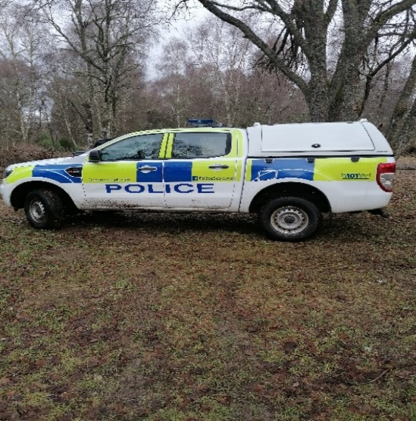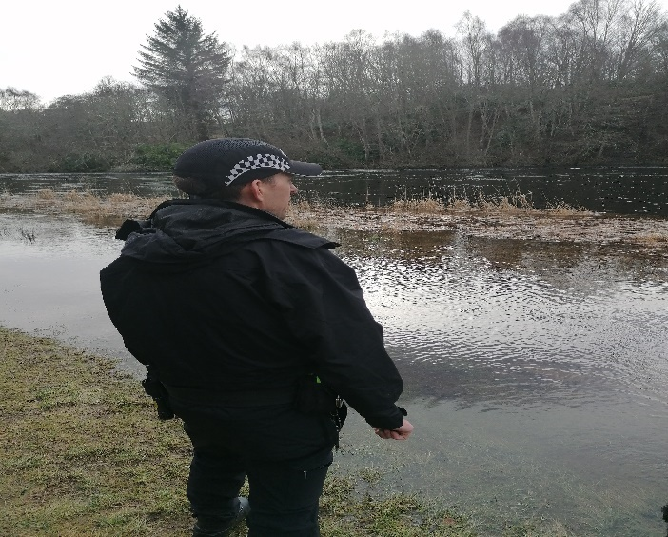

I will soon be working with our seasonal Bailiff who joins the team in April, and we will conduct patrols across the catchment area. We will undertake a combination of early morning, daytime, twilight, and night patrols during the season to try and deter potential poaching activities within our catchment.
Fisheries Officer tasks completed
Smolt trap - Purchased equipment for the Smolt trap.
-Carried out a survey of the River Farrar with the Senior Biologist for possible sites for a Smolt trap survey for 2022.
-Identified the river Glass smolt trap site. Smolt trap was installed and is up and running
-I attended several Teams meeting with the Senior Biologist and members from SSE to discuss fish counts/Smolt timings, run and contact details of personnel to contact on the dams.
-Installed a temperature logger which is now up and running on the river Glass
SISI - I have taken over the day to day running of the SISI program.
-I have dropped off Mink equipment to volunteers within our catchment.
Predation monitoring- I keep sawbill and seal sightings and management records up-to-date within our catchment.

Kelt monitoring - Checking for Salmon and Sea Trout Kelts above the Dams during February and March. No kelts were observed.

Admin -Getting myself up to date with the shared folder.
-Updating the facebook page
-I will complete a quarterly report for all board members and proprietors.

Please feel free to contact me regarding any issues on the river. In the meantime, I will continue to patrol the catchment, and work from home and can be contacted by email or phone.
Ali Skinner
Fishery Officer

Contact Details
Email: ali@beaulyfisheryboard.org
Tel: 07786 741482

