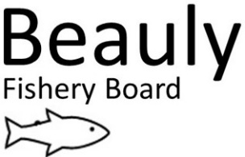 AS 03/09/21
Fisheries Protection – Quarterly Report
I have now been in post for just over 8 months and am really enjoying the challenge. I have a varied role, and this includes working with the Senior Biologist, Seasonal Bailiff, Ghillies and volunteers.
It has been great to meet with some proprietors and anglers and learn about the Rivers Beauly, Glass and Farrar, and the Beauly Firth. The seasonal Bailiff and I are currently patrolling the catchment 14hrs per day on split shifts, undertaking a combination of early morning, daytime, twilight, and night patrols and weekend patrols throughout the season to try and deter potential poaching activities within the catchment.
I met with Glass syndicate Bailiffs to discuss operational joint working and the sharing of any possible poaching incidents.
I have been in contact with the Bailiffs from the Ness Board and Cromarty Board to share any Fisheries intelligence.
The wildlife cameras have been deployed, but as of yet no poaching incidents have been recorded.
I also attended a basic half day training course on drone training.
Alastair Campbell and I attended a meeting with the District Assessor to discuss beat boundaries and owners. A map of the Beauly catchment showing the beat boundaries and ownership will be produced and shared in due course.
River Patrols conducted 25 May-3 September 2021
River | Patrols | Warning Letters Issued
BAC water | 56 | 0
Beauly - Lower and Middle | 125 | 3
Glass | 86 | 0
Farrar | 42 | 0
Beauly Firth | 82 | 2

Beauly Firth
82 patrols were conducted within the Beauly Firth. One angler was observed fishing from a rib. When challenged on his arrival into Kessock pier he could not produce a permit to fish the Firth and was issued with a warning letter. No fish were onboard his rib. One person was observed fishing below the Kessock bridge and when challenged, had no permit and was also issued with a warning letter.
I have received numerous phone calls reporting possible poaching in the Beauly Firth by small scale vessels and I am carrying out as many patrols as possible. Several vessels have been inspected on arrival into Kessock pier and only Pollack and Mackerel have been found.
I will contact Marine Scotland Compliance to request they deploy one of their inshore vessels to carry out rib patrols within the Inner Beauly Firth.
Beauly Angling Club and Syndicate Waters
181 patrols were conducted on the Beauly Angling Club (BAC) waters and Lower and Middle beats of the syndicate. I have spoken to several youths regarding fishing the BAC waters without a permit.
Three anglers were removed from the syndicate waters for fishing without a permit and fishing with the wrong tackle. They were fishing from the Beaufort Castle bank. They were issued with a warning letter and all fishing equipment was seized. They had no Salmon. I contacted the owner, and gained access to the Castle grounds to carry out patrols in the area. I also received permission to set the wildlife cameras in the area. I have permission to carry out ongoing patrols on the Castle bank.
1 Monofilament net was found on a Saturday night patrol between the two dams. I suspect we disturbed the poachers as a vehicle kept driving around the area.

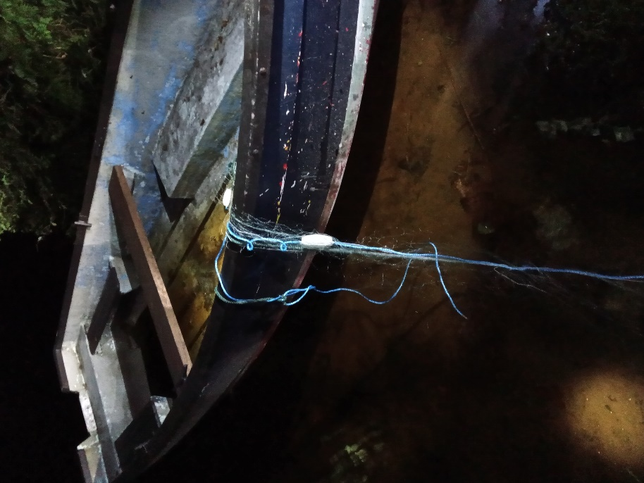
Monofilament net found in boat.

Glass
86 patrols were conducted on the river Glass during June, July and August and no fishery incidents were recorded. Very few anglers were fishing the river until August.
I received a report from one of the Glass bailiffs regarding a person fishing from a kayak on the River Glass. I patrolled the area but did not find any kayak. On one patrol, I noticed the fishing hut at Balmore beat 6 had been broken into. I reported this to the proprietor who said they would investigate.

Farrar
42 patrols were conducted on the river Farrar and small-scale fisheries issues have been addressed so far (no permits). I received reports of persons spinning in the area but as yet, I have not found anyone actively spinning to challenge them.
I have met with several SSE employees in the Farrar catchment and have given them both mine and the seasonal Bailiffs contact details. The gate keeper handed in a fishing rod case that they had found in the bushes. This case was for a folding rod.
Police Scotland
I organised for the seasonal Bailiff and I to carry out a second joint patrol with the local Wildlife Crime Officer from Police Scotland. This joint river patrol was on the upper Beauly and Glass in June. We patrolled the Fasnaklye and Cannich areas downstream through the river Glass. This collaborative approach will be ongoing to deter any illegal fishing.
I also met with the Police Constable based in Fort Augustus who carries out patrols in the area.
I attended a video conference with Police Scotland’s Senior Wildlife Crime Officer regarding operation Wingspan. This is a joint venture between local Wildlife Crime Officers and Salmon Fishery Board Bailiffs to deter any wildlife crime within our catchment.
All poaching incidents are passed onto the Wildlife Crime Officer to record on Police Scotland’s data base.
Strategy
I have fostered excellent working relationship with the Bailiffs, Ghillies, river watchers and staff from SSE. As previously stated, I have arranged for the catchment to be patrolled 14 hours a day (where possible), through a combination of patrols during the season to try and deter potential poaching activities within the catchment.
We continue to keep a very high profile to deter poaching activity on the rivers and along the coastline. Whilst poaching activity may be declining, there is no doubt that without the dedicated professional work of the BFB Bailiffs, the rivers Beauly, Glass and Farrar would be far more of a target for such illegal activity.
Members of the BAC have been very helpful passing on information on suspicious behavior and of strange cars parked at the river. I have found the local Police Wildlife Officers to be a great source of information and they have also been extremely helpful when I have had to contact them.
I also have an excellent working relationship with my fellow Bailiffs from the Ness and Cromarty and keep in regular contact with them.
Please feel free to contact me regarding any issues on the river by email at ali@beaulyfisheryboard.org or by phone on 07786 741482.

Ali Skinner,
Fisheries Officer /River Bailiff

