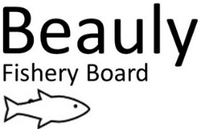 Interim Proposed Action Plan v2 RW updated post board meet 23 September 2021
In the absence of an approved Fishery Management Plan, here is the proposed Action plan discussed at the board meeting on 23 September (based on the 2021 Annual Report and current Operational Programme).
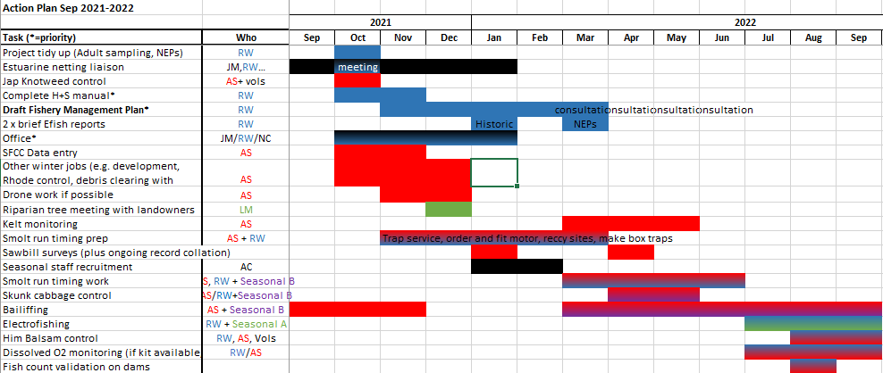

Other work not included here may be less of a priority to ensure time for the FMP to be written.
Key considerations:
-Smolt monitoring 2022 will include improved monitoring on A.Deabhag and box trapping on the Farrar (provided suitable box trap sites are found).
Staffing/ Funding:
-Seasonal B bailiff/ smolt trapping staff to be paid for by the board?
-Seasonal A to be paid for by NEPS money. From this pot we could keep tree work going. (See Temperature and Trees doc).
-Also hope to recruit an intern for smolt trapping and EFishing.
FMP will cover future actions including:
-Monitoring for Smolt run timing to inform flows and improve smolt survival through Aigas and Kilmorack turbines. Beannacharan dam smolt behaviour- acoustic tagging.
-Riparian tree planting to keep waters cool so fish survive better in the context of warming temperatures (climate change). Also other benefits (nutrients and habitat).
-Hydromorphology survey for better sediment and flow management for better fish spawning and juvenile habitat.
- Invasives control. To ensure invasives do not start impacting fish habitat, fish and for general biodiversity.
-Estuarine netting (Marine Scotland and Ness DSFB liaison to either close or change jurisdiction of netting stations) to ensure fish are not netted in the estuary.
-Predator monitoring and control. To reduce the impact of predators on salmon and sea trout.
-Barrier assessment and removal. To ensure manmade barriers are eased where this is feasible and that the habitat upstream justifies this to allow access for adult spawners and also juveniles in their natural range.
Once the first draft has been written it will be disseminated to stakeholders for comment.

