Temperature and Trees v2 RW original 13/09/21, updated 27/09/2021
Background
“Atlantic salmon, are adapted to live in cool water habitats. Juvenile Atlantic salmon perform best when temperatures are in the mid-teens, and struggle where temperatures extend much beyond 20°C. At 23°C juvenile salmon experience thermal stress and behavioural change, that includes abandoning territories and searching for cool water refuges. Where temperatures reach 32°C juvenile salmon will die in the space of minutes. During the summer of 2018, it is estimated that around 70% of Scotland’s rivers experienced temperatures that exceeded this threshold for thermal stress. UK climate change projections provided by the MET Office (UKCP18) indicate that summers like 2018 could occur every other year by 2050, with increasingly high air temperatures and low summer flows.
Maximum summer river temperatures are primarily driven by solar radiation, moderated by characteristics of the rivers, the surrounding catchments, the volume of water in the rivers and their residence times. Water volumes and residence times can be increased by reducing water demand and abstraction. The amount of solar radiation reaching the river can be reduced through management of riparian (bankside) vegetation.
Riparian trees can shade river channels, reducing the amount of solar radiation reaching the water surface. By increasing the amount of trees on river banks it is possible to reduce river temperatures and mitigate some of the effects of climate change. Increased shading can also help to mitigate other pressures which are expected to be exacerbated by climate change…
Given the time taken to plan and implement appropriate planting, and for trees to grow to a height where they provide meaningful shading, it is important that efforts are made increase the spatial extent of riparian woodland as a matter of urgency. However, it is also important to prioritise efforts to river reaches where they can deliver the greatest benefits in terms of climate change adaptation.” (Scottish River Temperature Monitoring Network, [SRTMN])
Additionally:
Juvenile salmon cease feeding at 21°C despite being acclimatised to various temperatures (Elliott 1991).
Brown trout are even less tolerant of warm water temperatures.
Less oxygen is held by warm water.
Increases in temperature increases the susceptibility of fish to disease.
There are good examples of riparian tree planting projects to buffer against the impacts of climate change on many rivers including the Dee and Kyle of Sutherland.

The Beauly Catchment
Temperature modelling (SRTMN) has shown that the upper catchment and small tributaries likely experience temperatures at and above the thermal stress threshold for juvenile fish (Map 1).
Map 1: SRTMN Predictions of maximum daily river temperature for the hottest day between July 2015 and July 2016
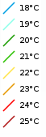
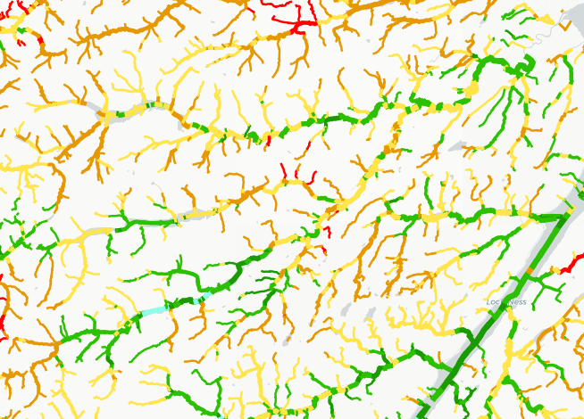
Temperature monitoring data from this year also suggests we approached the stress threshold for fish at the top of the R. Farrar (our own logger data) and on the mainstem Beauly (SEPA data) in summer (Graph 1). Please note at time of writing the Upper Glass logger had not been downloaded. The U. Misge logger is in shade, it is likely that shallower tributaries will have been hotter than this.
Graph 1: 2021 Temperature readings so far….
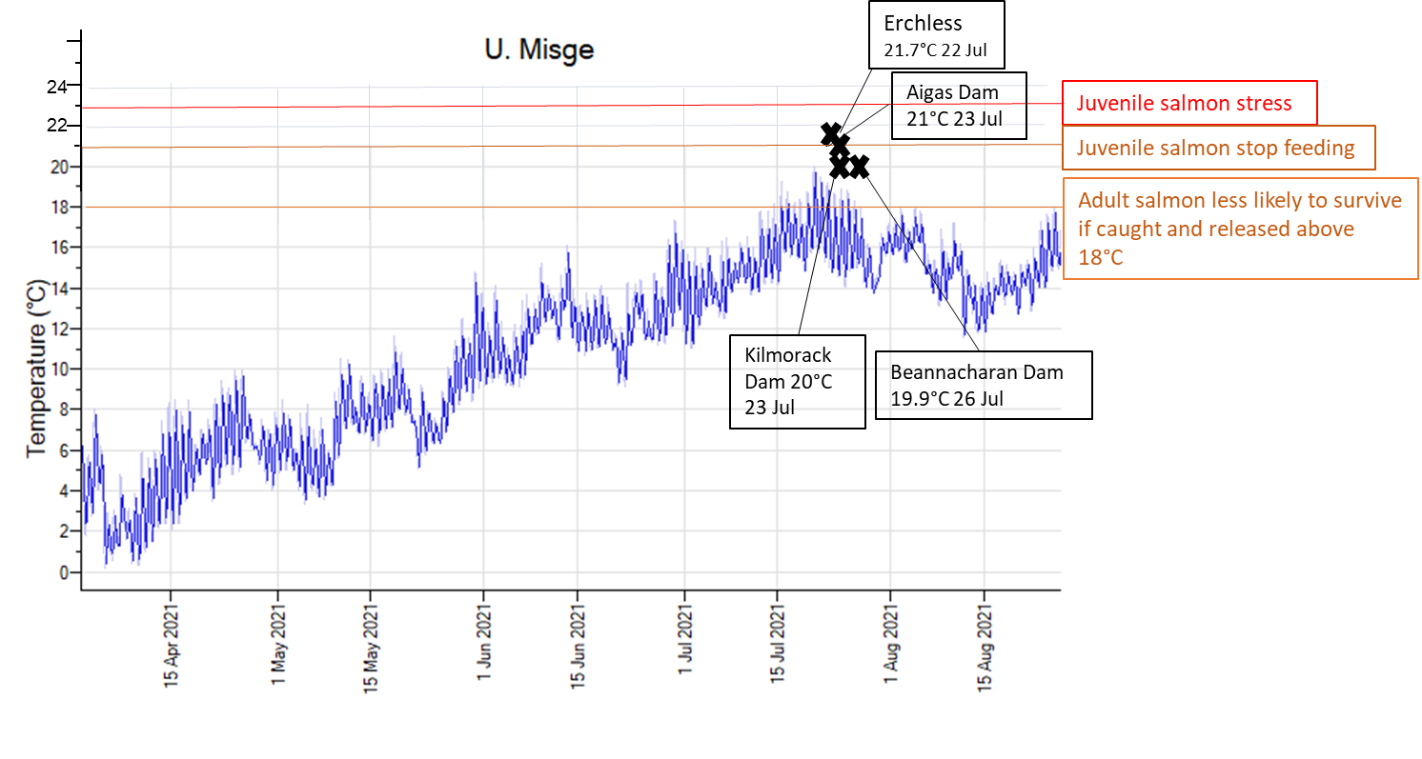
What can we do?
As water from the upper catchment ultimately ends up in salmon-accessible areas, and climate change will only make the situation worse we need to start taking this threat seriously. Riparian deciduous trees can significantly help to keep water cool by shading burns, but it takes years for them to grow so we should act now. As a board, we can encourage landowners to adopt riparian tree planting.
Luckily the SRTMN produced a Management Priority map to help us focus our tree growth encouraging activities (Map 2).
Lynn (our electrofishing contractor) has been putting some building blocks in place for encouraging landowners to adopt riparian tree planting and we hope to organise a winter gathering of landowners in the high risk areas with Riverwoods who can advise them of the best way to earn money from planting trees (carbon credits).
We will continue temperature monitoring.
Map 2: Scottish River Temperature Monitoring Network (SRTMN) Management Priority, Beauly catchment
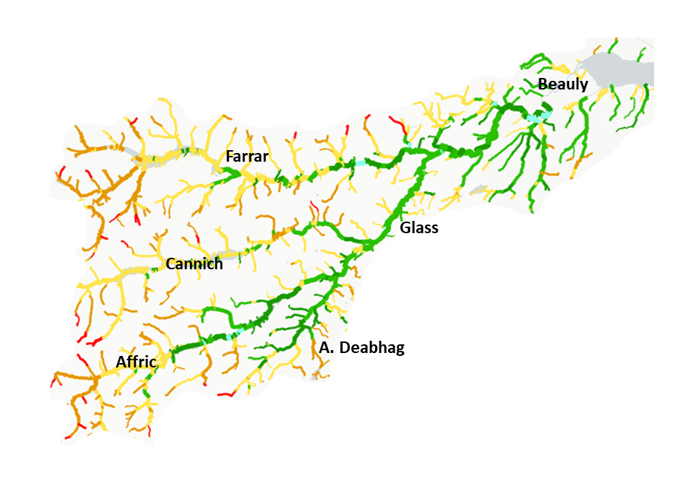

References:
Elliott J.M (1991) Tolerance and resistance to thermal stress in juvenile Atlantic
salmon, Salmo salar.
Scottish River Temperature Monitoring Network: https://www.gov.scot/publications/scotland-river-temperature-monitoring-network-srtmn/
View SRTMN maps (under Climate Change) here: https://marinescotland.atkinsgeospatial.com/nmpi/

