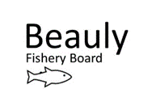
Biologist update RW 2 June 2022

This update summarises key work tasks completed since the last update 18 March 2022. March-May’s focus has been on carrying out smolt monitoring, hydro-morphology (fish habitat and substrate) walkovers on the Affric and Cannich and helping Louise with the Oral history project. Monthly team meetings occur between Jock, Ali and me.
A Better BFB
Kit- A work mobile was purchased for the Seasonal Bailiff. We have been gifted a second hand electro- fishing back-pack by an LBFS angler. We have been given 50+ PIT tags for PIT tagging smolts by SSE.
Office accom- The first round of joinery has been done thanks to TW managing contractors but more is due to happen.
H & Safety- We had one H+S incident of a volunteer poking her eye on a branch whilst helping clear access for future Japanese knotweed control but was treated with eye-wash and is well now.
Staffing- Louise our Trainee fisheries Officer (funded by Naturescot and Skills Development Scotland) is carrying out the Oral history project and has been invaluable in helping us deliver our smolt monitoring and walkover surveys. Bob our Seasonal Bailiff is getting on well in the team and apart from bailiffing has helped on a weekly basis checking the Farrar box traps.
Fishery Management Plan- A small number of tweaks were made to the draft having had some feedback and was distributed to proprietors. We are still waiting to hear if funding might be available for FMP updates so the draft has not been distributed to external stakeholders yet. Please get in touch if you have any comments (big or small).
Annual Report- contribution complete.
Future: A couple more weighing slings and electronic weighing scales will be purchased ahead of commencement of the National Adult Sampling Project. We will need to recruit 2x UHI interns shortly (for efishing) and put them on first aid training. If FMP funding is available will need to update our draft, otherwise it will be distributed to external stakeholders in due course. Steve Fraser (Braulen keeper) has agreed to make us a box trap for next year. Will need to cost up and buy materials. If Ness and Beauly Fishery Trust is to remain active, various trust models need to be looked at to see how we might fund this. We need to procure or borrow a PIT tag decoder if we are to commence this work next year (either to assess trap efficiency or possible delays to migration in assoc with Bennacharan dam).
People: Community engagement, participation and heritage
Oral history Project- 10 interviews completed by Louise. This project is about us listening to folk in the catchment and gathering their insight (and old photos). Any future changes we may want to make to the river/ land-use involves people so this is a chance to build rapport, listen and learn about how things have changed. Louise has time to give 2 more interviews, still waiting to see if any previous LBFS ghillies will be interviewed.
Riverwoods film- Attended the local showing at Drumnadrochit (Scotland the Big Picture), answered questions afterwards as part of a panel with Brian (Ness Board) and Alan McDonnel (TFL). Am waiting to hear if I may distribute the link for others to view. Summarises how salmon are linked to the wider landscape and the importance they play in ecosystem function.

Furthering our understanding
Smolts- 4ft RST at Fasnakyle got damaged having captured 130 smolts on 5 April. Trial box trap monitoring on the Farrar became our main monitoring and smolts were recorded between 5 April-6 May. Phase 2 of the protocol was in place 25 April- 28 May.
Fish habitat/ substrate walkovers- The walkovers of the Rivers Cannich and Affric to look at whether the lack of fish spawning and fry habitat at the bottom of both rivers is natural or not are complete and report writing is underway.
SSE- We had a day with SSE (23 May) and they showed us how they estimate the numbers of smolts at the gate slots at Aigas and Kilmorack (similar number of smolts seemed to be there compared to last year) and we showed them potential smolt monitoring options and highlighted the seeming lack of spawning substrate on the Farrar compared to 1935. See photo. Good to chat with Graham MacDonald (Affric-Beauly Team Leader). SSE may provide us with a 6ft RST trap to be run at a good and safe site a few km upstream of Aigas for future monitoring- to be confirmed.
Adult fish- Marine Scotland 2021 report is now on the website. Preparation is underway with the LBFS ghillies for this season. Big thank you to them for last year. Findings : Moray Firth- Out of 112 fish with readable scales 75% captured were grilse, 25% 2 Sea winter fish (no 3 SW fish). c75% of fish smolted as S2s (2 years in freshwater). Most Grilse were 58-63cm, most 2SW fish 70-81cm. Biggest (length and weight) fish sampled were in Moray and East region.
Drone work- not carried out on R. Cannich or Affric as hoped due to breeding bird season.
Future: Smolt report to be written. 2022 EFishing was decided to include Cannich, Affric and Coastal burns with some invertebrate monitoring but emphasis may change slightly in light of walkover findings and the fact we should probably gather baseline data on Glass tributaries in light of the ‘Beaver’ information below. Adult sampling set-up to be completed. Jim and Ali have been tasked with drone surveying the Japanese knotweed on the Lower Beauly as a test flight.
Improving ecosystem processes
Beavers- FLS environmental advisor has highlighted that Scottish Government will be translocating ‘overspill’ Tay beavers to FLS land at 2 locations in Scotland this autumn. IF they choose to translocate them to the north region then it will be a choice between the Spey or the Beauly catchment. Official consultation will occur in due course between Scottish government, FLS and wider stakeholders. We should ask in what form of support they will be providing if/ when Beauly is chosen.
Invasives (INNS)- Beauly Balsam Basher Meeting (13 April) occurred at the Priory Hotel to co-ordinate volunteers.
Japanese Knotweed (JK)- two afternoons (with 1-2 vols) have been spent clearing access on the Lower Beauly for Japanese Knotweed control later in the season. We are lucky to have 2 trained volunteers eager to help us treat the large patch on the lower Beauly (will give 2 weeks of their time) so we are supporting them with this (August and October).
Skunk Cabbage (SC)- One afternoon digging up Skunk cabbage at Mauld. Gained permission from Kirkton burn landowner- AS to treat. AS treated a new patch of SC on the Glass.
Mink- AS continues to support the mink volunteers although vol numbers are dwindling.
Riparian Trees- Smolt trapping on Braulen estate and seeing estate staff on a daily basis has improved our relationship. Braulen is our priority area for encouraging riparian trees based on the current lack of trees in places up there. Attended Riverwoods (SWT) training, Kingussie (31 March).
Seal licensing- AS to purchase paint ball gun for ghillies.
Coastal Netting- meeting occurred between ourselves and Ness board 4 April, Brian has been tasked with furthering discussions with FMS and MS.
Future: SISI are paying for me to go on herbicide training (11-12 June). This will help make us more resilient especially as Ali may only be able to do limited spraying and stem injection. Am still to map the proposed tree planting areas for Braulen’s approval, will be enlisting the help of Trees for Life’s Riparian Officer come July. Need to check if LBFS ghillie is registered on Seal course. Need to contact proprietors about tributary/ blockage clearing.
No Incidents
Written outputs: Annual report contribution. Riverwoods film email to proprietors. Draft FMP email to proprietors. River-bank work RA.
Meetings/ phone calls: SSE liaison meeting (22 March), Riverwoods (SWT) training (31 March), Ness board meet (4 April), Riverwoods film preview (Drumnadrochit 21 May), SSE visit at dams (23 May).
Postcard collected by Richard Wood of photo taken 1935 on the Farrar (at what is now the FAR2 electrofishing site) showing a prevalence of spawning substrate which is no-longer there. Photo taken whilst out with volunteer Tim 15 May. Gathering more old photos and comparing ‘then’ and ‘now’ will help our understanding of how hydro dams may have affected fish habitat in the catchment.
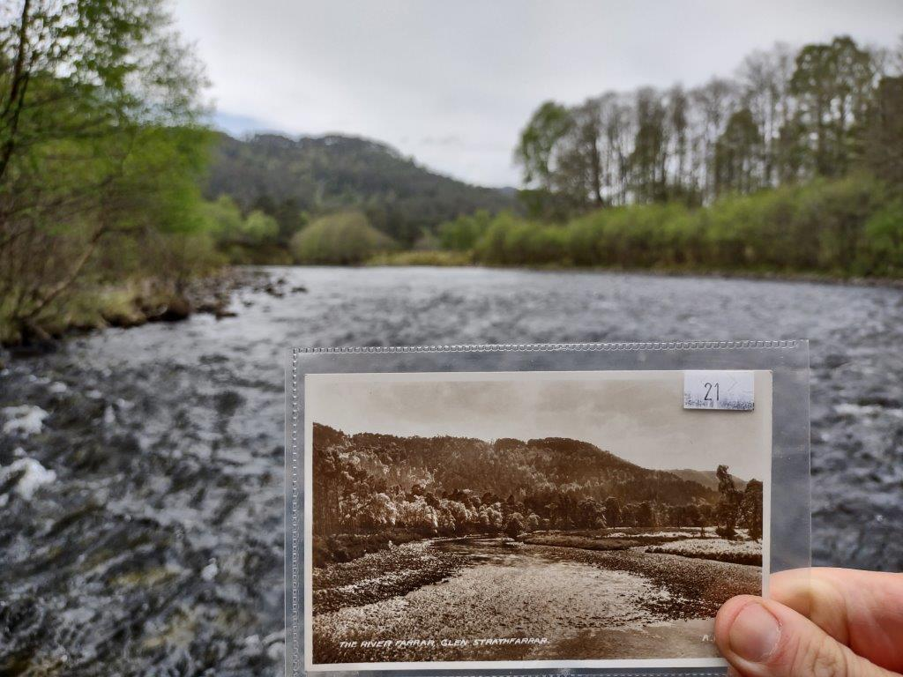
Summary smolt monitoring graph
