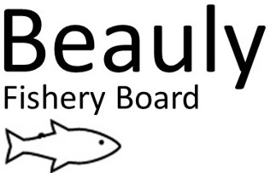
AS 8 Sep 2022
Fisheries Protection

The Fishery Officer and Seasonal Bailiff had an extremely busy May, June, and August with over 54 call outs during this period, mostly at the weekends. Most off these call outs were for anglers targeting Brown Trout and Pike within our catchment. Several rods were seized, and fishing rods were also found by the water bailiffs, hidden in the undergrowth where anglers had tried to hide them from us. One monofilament net was lifted from the Beauly Firth. We continued to keep a very high profile to deter poaching activity on the rivers and along the coastline. Whilst poaching activity has been on the increase this year, there is no doubt that without the dedicated professional work of the BSFB Bailiffs, the rivers Beauly, Glass and Farrar would be far more of a target for such illegal activity.

Monofilament net and Rods and Tackle seized by the Beauly Water Bailiffs

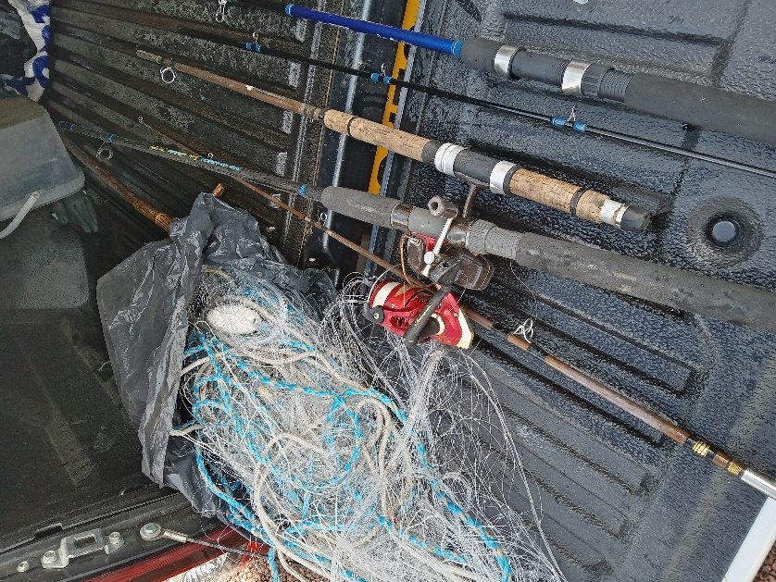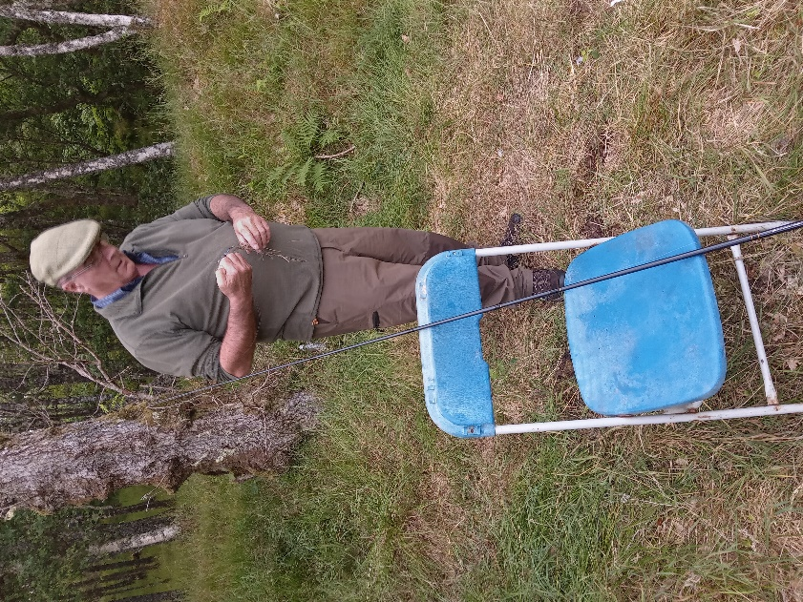

Joint river patrol with Police Scotland (6 September).

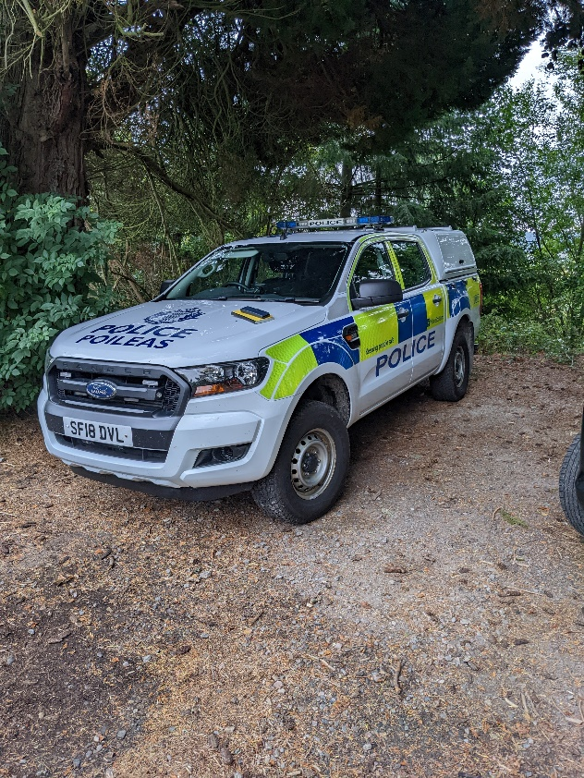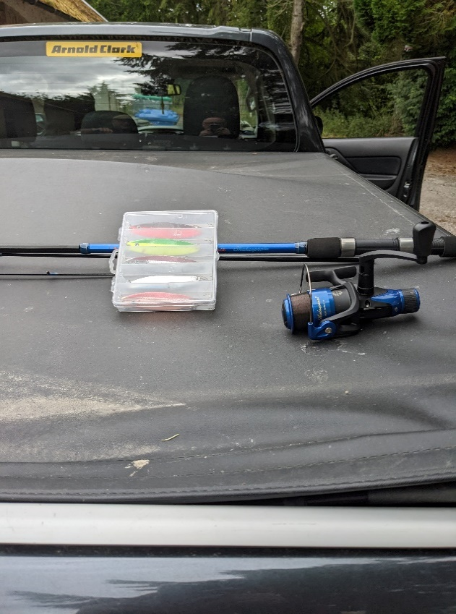

Before and after - treatment of Skunk Cabbage on Kirkton burn (June)

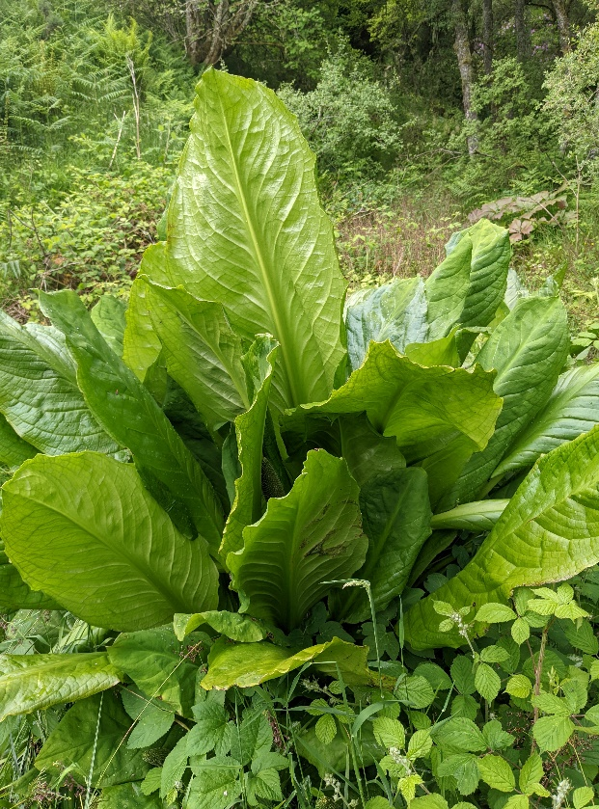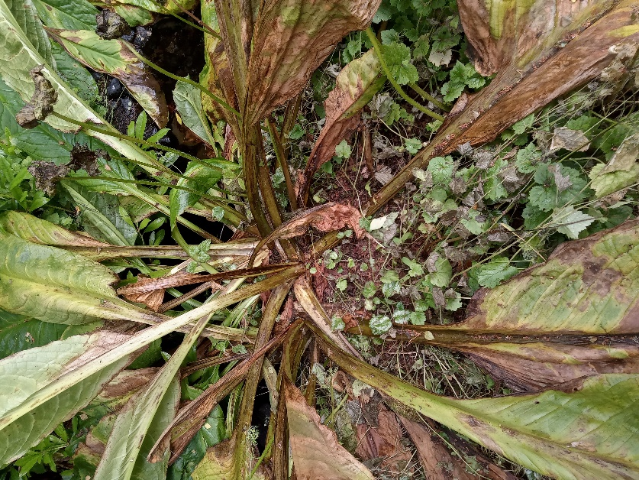

River Patrols May - Sep 2022

The total numbers of patrols from 25th May – 7th Sep 2002 (carried out by both the Fishery Officer and Seasonal bailiff) are shown below.

River | Patrols (25 May 2022-08 Sep 2022) | Warning/Verbal warnings Letters Issued
BAC water | 78 | 1 Warning letter  1 Verbal warning.
Beauly -Syndicate and Middle | 150 | 4 Warning letters.  10 Verbal warnings
Glass | 82 | 8 Verbal warnings
Farrar | 28 | No major issues.
Beauly Firth | 90 | 1 warning letter, 18 verbal warnings.

Beauly Firth

90 patrols were conducted within the Beauly Firth. One person was observed fishing below the Kessock bridge and when challenged, had no permit, and was issued with a warning letter.

One Multi mono net was found on the shoreline while carrying out a night patrol and information passed onto Police Scotland.

I have received numerous phone calls reporting possible poaching in the Beauly Firth by small scale vessels and have been carrying out as many patrols as possible. Several vessels have been inspected on arrival into Kessock pier and only Mackerel have been found to date.

Sea Bass fishermen are fishing the Red Castle area of the Firth. Advice was given to the anglers on size limit and how many fish they can retain.

Syndicate - Middle Beauly

150 patrols were conducted on the Middle and Syndicate beats. I have spoken to several youths regarding fishing the beats without a permit but most of these anglers are using Trout gear and tackle. Spinning tackle was found by the Ghillies on the Falls beat.
Ghillies removed two anglers that were about to fish the Falls beat.
The Water Bailiffs removed eight anglers from the LBFS beats on eight separate occasions in this time period.

Two Seals were spotted on the Downie beat during this period.

Glass

82 patrols were conducted on the river Glass during this period. We keep in regular contact with the Bailiff and Ghillie from the Glass and pass on any information on poaching. Anglers are purchasing Pike/Trout permits but fish the main river.

There has been a massive increase on anglers fishing the river Glass for Brown Trout during this period. One possible fisheries case was forwarded to Police Scotland.

Farrar

28 patrols were conducted on the river Farrar and several small-scale fisheries issues have been addressed so far. These issues have been no permits and anglers buying a Trout permits but fishing with Salmon tackle.

We have an excellent working relationship with the Ghillie on the Farrar.

Offences Reported

I reported one incident (from the R. Glass) involving a YouTube video to Police Scotland and asked that they investigate further. Unfortunately this case could not be taken further.

General duties I have undertaken in June 2022 - Sep 2022:
- Monthly team meetings with the Chair, Deputy Chair and Senior Biologist.

Enforcement
- I designed a warning letter receipt book and had it produced.
- I have regular catch ups with the Glass syndicate Bailiff and Ghillie to discuss operational joint working and the sharing of any possible poaching incidents.
- Daily contact with the seasonal Bailiff for operational purposes.
- Deployment of the wildlife cameras throughout the catchment (no poaching incidents have been recorded so far).
- Several patrols were arranged with Officers from Police Scotland. This will be an ongoing exercise.
- Carried out regular patrols in the catchment and around the Beauly Firth.
- I am currently arranging a joint patrol with Marine Scotland compliance as they had to cancel the previous 2 dates I had arranged in July and August.

Scottish Invasive Species Initiative
- SISI claims were submitted on time.
- SISI Volunteers hours recorded on CERVIS system.
- Distributed Mink equipment to volunteers.
- Three Japanese Knotweed sites were treated.
- Skunk Cabbage was treated at Kirkton burn.

SSE
- The fish count validation at Kilmorack and Aigas dams was carried out to check the accuracy of the counts.

Predation
- Paintball gun was purchased and given to LBFS ghilies for Seal scaring.

Strategy
I continue to foster excellent working relationship with the Bailiffs, Ghillies, river watchers and staff from SSE. As previously stated, I have arranged for the catchment to be patrolled 14 hours a day (where possible), through a combination of early morning, daytime, evening and night patrols during the season, to try and deter potential poaching activities within the catchment. All weekends have been covered from June – September.
I also have an excellent working relationship with my fellow Bailiffs from the Ness and Cromarty and keep in regular contact with them.
Please feel free to contact me regarding any issues on the river by email at ali@beaulyfisheryboard.org or by phone on 07786 741482.

Ali Skinner,
Fisheries Officer /Water Bailiff

