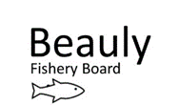
Senior Biologist update RW 6 September 2022

This update summarises key work tasks completed since the last update 2 June 2022. June-September’s focus has been on getting electro-fishing done on coastal burns and fry sampling for the Farrar genetics project. A brief smolt report and updating the draft Fishery Management Plan in response to comments received will hopefully occur in time for the September board meeting. Monthly team meetings occur between Frank, Mike, Ali and me (Jock resigned as chair on 14 June).
A Better BFB
Kit- Kit serviced by Fraser, one collected, one still up in Ardgay. SSE have ordered us a 6ft rotry screw trap for spring 2023 smolt monitoring. We are also getting a freezer from the SISI project.
Office accom- Office and Corff building renovations almost complete thanks to TW. WC floor, and a few small things left to do.
H & Safety- Grey vehicle scraped.
Staffing- Louise finished her contract with us 17 June, all invoices and evaluation to NatureScot complete. We did not manage to secure a UHI student to help with Efishing this year which has limited us to surveying small sites only. So far have used Bob (seasonal bailiff) and volunteers for Efishing. Will use TFL, UHI and Beaver Trust staff for September’s beaver baseline work. We hope to get a trainee next year either through Working with Rivers (6 months Apr-Sept) or New to Nature (1 year- recruitment from under-represented groups).
Fishery Management Plan- Feedback received from proprietors including SSE after consultation extended to end of July. Updates done. Funding will be available for storyboard format FMPs in early 2023 through FMS.
Future: Will need to purchase a PIT tag decoder, procure smolt trap materials for Steven (Braulen), and get RST anchors made. Office lease agreement between us and LBFS needs writing. Safety signage, extinguishers etc need sorting before move into office. Would be good to purchase a set of Big Dug shelving for store as well as a few bits and bobs, perhaps some office shelving. NBFT funding needs to be discussed at board meeting. Draft FMP needs putting on website once approved by the board. Apply to host a trainee once scheme details have been finalised- would need to buy another laptop.
People: Community engagement, participation and heritage
Engagement with the community has mainly been through volunteer efishers (Emma, Ivar, Dan, Steve, Cat) and through the Beauly Balsam Bashers (Steve, Mary, Jackie, Craig, Ivar, Helen, Maria, Cat, Kapka), see ‘Invasives’.
Oral history Project- Louise (now as a volunteer) is transcribing the interviews so they can be maximally useful- thanks Louise!
Paper on history of old fish traps received from Steve (volunteer).
Future: Once Oral History material has been archived with Am Baile we will make the old photos and transcriptions accessible.

Furthering our understanding
Electro-fishing- Efishing of coastal burns is now complete with a total of 18 surveys complete (including 4x 3 run sites). Coastal burns now added to SFCC database. Good to see juvenile salmon in Redcastle, Tomich and Moniack burns, but some agricultural issues found.
Farrar genetics sampling complete. Hosted Victoria Pritchard (UHI) for a Farrar site visit.
September efishing will be to get a beaver baseline (awaiting access permission from FLS) with invertebrate samples with UHI, TFL and Beaver Trust.
Provided updated sample frame to MS for NEPs 2023.
Fish habitat/ substrate walkovers- 2022 Rivers Cannich and Affric report to be written over the winter. Pre-hydro photos of Farrar received from MSN 18 July. Considering if we could get a quote from CBEC (hydro morph consultant) to get a list of recommendations for restoration and put in a funding app to NRF in 2023?
Adult Sampling- LBFS ghillies sampled/ measured 61 adult salmon between 16 June- 23 July, data has been checked and work for the first period has been invoiced for, we are now in the second sampling period.
Red Skin disease app shared to proprietors by AC.
SSE- Fish count validation work occurred between 15-19 August with Naveed (SSE Environmental advisor). See Appendix 1 for more information. Artificial intelligence counter (Aigas) and new mark 14 counter (Kilmorack) currently being trialled. Fish counts received up to end of June.
Main finding: Initial indications show a minimum level of accuracy of 71% which is consistent with SSE’s estimation of 65-75% accuracy.
Dissolved Oxygen (DO) monitoring- Monitoring was done 12 Aug in an upstream direction at 6 sites in the catchment after a period of warm weather. See Appendix 2 for more information.
Main finding: DO did vary between sites with temperature and DO being lowest below Kilmorack dam, with highest DO found above the influence of Aigas. All readings showed oxygen (recorded as 8.8-9.4mg/L) and water temperature (recorded as 14.7-16.5°C ) to be well within the limits necessary for adult salmon migration (>5mg/L, and 5-22°C).
Smolt monitoring- Temperature logger data downloaded 1 + 4 July.
Freshwater Pearl Mussels (FWPM)- Attended training- It is thought the Beauly populations are not producing larvae.
Future: Need to deliver Farrar samples to UHI. Smolt report to be written- awaiting data from SSE. Efish report due to be written over the winter. Efishing to support habitat/ hydromorph findings due to be done in 2023. Data gathering/ survey required to check state of FWPMs, then decide if glochidia seeding necessary.
Improving ecosystem processes
Beavers-Trees for Life are proposing to translocate beavers from the Tay to the upper catchment. Consultation is underway until October. Information to help proprietors and landowners make informed responses is here.
Invasives (INNS)/ Scottish Invasive Species Initiative (SISI)- All invasive control work in the catchment is funded through SISI. We fed into SISI’s EOI for getting funding from the Nature Restoration Fund for Phase 2 of the project. We hope to have a Project Officer shared with Ness and Conon.
-Himalayan Balsam picking by the Beauly Balsam Bashers has now finished. Picking was done between 16 June-30 August. Kayak access 18 Aug. Volunteer hours will be collated in due course. All sites were picked with the exception of Kinerras, one patch at Ferry field, and a few patches along Wetser Lovat- so another successful year.
- After thoroughly assessing the Japanese Knotweed on the lower Beauly with trained volunteers Cat and Steve, a small amount of stem injection was done but it was decided time would be better spent treating the JK at Struy and harnessing their time for efishing and Himalayan balsam pulling instead. We have submitted an expression of Interest to get £9,000 of funding from Nature Restoration Fund Highland to get a contractor to carry out the work on the Lower Beauly. Fingers crossed. AS has sprayed a few sites in the wider catchment.
AS continues to support the mink volunteers.
Riparian Trees- Braulen estate tree planting plans have been updated with input from Russ (Riverwoods SWT).
Predation- Paint ball gun has been given to the LBFS ghillies to help deter seals. Sawbill licence and return submitted 27 June.
Coastal Netting- Communications are ongoing between ourselves, Ness board and FMS. Netting occurred at Longman but not Rosemarkie the last two weeks of the season, and numbers are initially estimated at less than 50 fish being caught (netting effort was low) comms Brian Shaw. If mandatory catch and release comes in then this would put an end to the problem. FMS to go back to Scottish Government to make sure there is definitely no funding available for a buy-out.
Burn clearing- AS is contacting proprietors to assess burn clearing capacity to ensure free passage of fish by the end of this month.
Future: Board response to beaver consultation will need submitted after board meeting. Get stem injectors serviced. Tree maps to be sent to Braulen for further comment, site visit required with Catherine Wares (local Forestry Officer) and Paul Greaves (TFL riparian officer). We will continue to support the Beauly Balsam Bashers- as seed is viable for 3 years we need to hit it hard again next year (third year). SISI will put me on herbicide training. LBFS ghillie Seal management course to be organised by Bidwells. Coastal netting to be discussed at board meeting.
No Incidents
Written outputs: Sawbill licence application and return to NatureScot (27 June), Beaver briefing note produced for proprietors (16 Aug), FMS hydro group response (5 Sep), Conservation regs consultation (6 Sep).
Meetings/ phone calls: Efish Team leader refresher training (19+21 July), Met with NJ and GH (20 +22 July), FMS regional meeting with FSN (4 Aug), Russ Jobson tree planting advice (8 Aug), Freshwater Pearl Mussel Training (16 Aug). Several TFL/ Beaver Trust/ UHI meetings to co-ordinate beaver baseline monitoring. Victoria Pritchard (UHI) Farrar site visit with FSN for Farrar Genetics Project (26 Aug).
Cat and Steve (trained volunteers) treating Japanese knotweed at Struy (5 Aug)
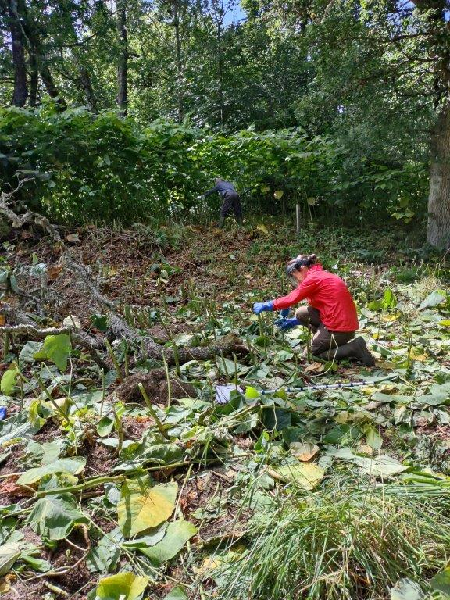

Appendix 1-Fish count Validation
Kilmorack Lifts: 08:20-09:20, 12:20-13:20, 16:20-17:20. Aigas: 08:30-09:30, 12:30-13:30, 16:30-17:30. Beannacharan: 09:18-10:15, 13:15- 14:15, evening lift.
No multiple exits were observed. Eels were also seen using the lifts. Unfortunately no salmon came up the fish pass at Beannacharan so another date is being organised for a re-visit.
Fish count validation initial findings (to be confirmed once we have access to fish counts)
 | Kilmorack (15 Aug RW + AS) |  | Aigas (18 Aug, AS) |  | Beannacharan (19 Aug, RW)
 | Observed | Recorded | Observed | Recorded | Observed | Recorded
1st lift | 24 (11 eels up, 17 down) | 19 (79%) | 7 | 5 (71%) | 0 (1 eel up) | ?
2nd lift | 22 | 18 (81%) | 3 | 4 (75%) | 0 (3 trout up) | ?
3rd lift | 14 (1 eel up, 2 eels down) | 10 (71%) | 14 | 12 (86%) | Not observed

Appendix 2-Dissolved Oxygen monitoring
This work was suggested last year in response to an incident where 3 dead adult salmon were found in short succession in July, raising concerns that water temperature and dissolved oxygen levels may have exacerbated the state of these fish.
NJ kindly lent us his DO probe. Monitoring was done 12 Aug in an upstream direction at 6 sites in the catchment after a period of warm weather. The probe was attached to a buoy so it hovered at approximately 0.9m depth. Sites were chosen to reflect where adult fish may rest. The probe was calibrated and took 25 minutes to settle before a reading could be taken. DO did vary between sites with temperature and DO being lowest below Kilmorack dam, with highest DO found above the influence of Aigas. All readings showed oxygen (>5mg/L) and water temperature (5-22°C) necessary for adult salmon to move upstream. The sites surveyed serve as a good baseline for future monitoring if required, although more sites would be ideal.
See summary table and map of sites below.
Dissolved Oxygen and temperature readings, 12 Aug
 | 30m d/s Kilmorack dam, NH49489 44190. 15:20. | 30m u/s Teanassie burn, NH47707 44005. 17:40. | 30m u/s Eilean Aigas, NH46313 41265. 18:45. | 50m d/s Erchless hut, NH41425 40260. 19:30. | Farrar, Whirlpool, NH40683 40124. 20:20. | Glass, 200m d/s Mauld bridge, NH40509 39724. 20:50.
Approximate Air temp (°C) | 23 | 22 | 20 | 19 | 19 | 19
DO (%) | 110.5 (8.8 mg/L) | 116.4 (8.9 mg/L) | 116.1 (9.0mg/L) | 120.3 (9.3 mg/L) | 119.0 (9.1mg/L) | 120.2 (9.4mg/L)
Water temp (°C) | 14.7 | 16.3 | 15.8 | 16.5 | 16.3 | 16.1
