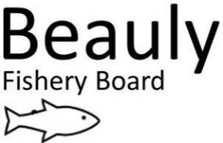 AS 08/03/23
Fisheries Officer/Water Bailiff – 9th January – 8th March 2023 Report

I have a varied role, and this includes working with the Senior Biologist, Seasonal Bailiff, Ghillies and volunteers.
The seasonal Bailiff started in mid-February, and I have been showing him the catchment and introducing him to various contacts across the catchment. Going forward, we will be patrolling the catchment 14hrs per day on split shifts, undertaking a combination of early morning, daytime, twilight, night, and weekend patrols throughout the season, to try and deter potential poaching activities within the catchment.
I keep in regular contact with the Glass syndicate Bailiff Addie Fraser, and Ghillie George Fraser to discuss operational joint working and the sharing of any possible poaching incidents and information.
I also keep in regular contact with Police Scotland’s Wildlife Crime Officer and the Water Bailiffs from the Ness and Cromarty Boards to share any Fisheries intelligence.

Beauly Fishery Board
- Attended SSE meeting with Senior Biologist and board members.
- I entered the Beauly’s Fishery Management Plan onto a spreadsheet. (Storybook)
- Life jackets were serviced, and equipment purchased for the coming season.
- Monthly team’s meetings were held with the Chair FSN, MSN, the Senior Biologist and TW to discuss operational plans for the coming season.
- My yearly review was conducted by FSN and MSN.
- Attended excel course at the UHI.

People: Community Engagement, Participation and Heritage
- Attended the opening of the 2023 Salmon season.
- The Boards Annual report was printed and is available in all Syndicate huts.
- Regular posts on Facebook.

Monitoring
Kelts
- Checking for Salmon and Sea Trout Kelts above and below Kilmorack and Aigas dam throughout the months of January, February, and March.
- Two Kelts were observed below Aigas dam.
- No Kelts were observed above Aigas Dam.
- The Aigas dam sluice gate was opened in early February for 8hrs.
- No Kelts were observed above or below Kilmorack dam.
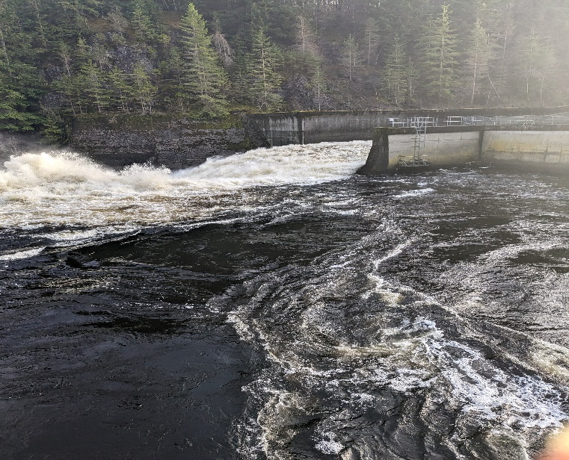
Sluice gate open on Aigas dam early February for Kelt release.

Smolts
- I will be monitoring the 6ft smolt trap at Grant pools on the Upper Beauly and Box traps at Fasnaklye and the Farrar from April until the end of May on a rota basis with the Senior Biologist, Seasonal Bailiff, Trainee, and volunteers.
- Purchased equipment for the Smolt trap.

Predation
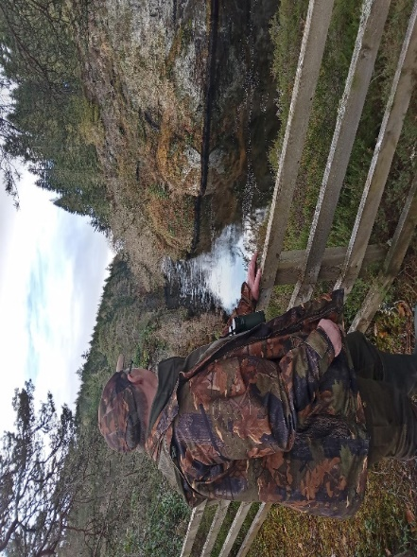
- Bird count was arranged and completed in January with help from BAC volunteers and the sawbill data sheet updated. A further bird count will be arranged for early April.

Bird count with Volunteer from the BAC at Aigas gorge
Other monitoring work
- Installed river temperature logger on the Tomich.
- All Electro fishing data sheets were entered onto the SFCC website.

Work to address the pressures faced by Salmon and Sea Trout
Bailiffing

River Patrols conducted 9 Jan – 8 March 2023
River | Patrols | Warning Letters Issued
BAC water | 38 | 0
LBFS – Upper Beauly beats | 38 | 0
Glass | 24 | 0
Farrar | 3 | 0
Beauly Firth | 34 | 0

A meeting has been arranged for mid-March with the Boards Fishery Officer and Seasonal bailiff and LBFS Ghillies and Ghillies from the Glass and Farrar to discuss joint working practise.
Showed our seasonal bailiff the Beauly Catchment and introduced him to the river Ghillies- SSE staff and BAC anglers.
- Initial catchment patrols were arranged with Police Scotland’s Wildlife Crime Officers, and this will be ongoing throughout the season.
- Marine Scotland Compliance was contacted about a joint Rib - land patrol with the Beauly Bailiffs and Marine Scotland Fishery Officers on the Beauly Firth, this was agreed for July- August this year.

I continue to foster excellent working relationship with the Bailiffs, Ghillies, Police Scotland’s Wildlife Crime Officers, river watchers, volunteers, and staff from SSE

Invasives (Scottish Invasive Species Initiative)
- Completed the SISI return and contacted our mink volunteers regarding Mink equipment.
- Mink Remoti devices arrived and were set up on the data base and ready to be installed in March.
- Attended a SISI meeting with staff from other Boards and Trusts.
- SISI Volunteers hours were recorded on the Cervis database.
- Cervis was updated with new volunteers.

As previously stated, I have arranged for the catchment to be patrolled 14 hours a day (where possible), through a combination of patrols during the season to try and deter potential poaching activities within the catchment. I also have an excellent working relationship with my fellow Bailiffs from the Ness and Cromarty and keep in regular contact with them.

We will continue to keep a very high profile to deter poaching activity on the rivers and along the coastline. This consists of carrying out a lot of late night and early morning patrols. Whilst poaching activity may be declining, there is no doubt that without the dedicated professional work of the BSFB Bailiffs, the rivers Beauly, Glass and Farrar would be far more of a target for such illegal activity.
Please feel free to contact me regarding any issues on the river by email at ali@beaulyfisheryboard.org or by phone on 07786 741482.

Ali Skinner,
Fisheries Officer /Water Bailiff

