Senior Biologist update RW 13 March 2023

This update summarises key work tasks completed since the last update 25 November 2022. The focus of the last three months was to finalise the smolt report, write the electro-fishing report, draft necessary Beauly Fishery Board Policy, and support the transition of our Fishery Management Plan into Storyboard format. Additionally, recruitment has occurred for the Seasonal Bailiff and our Working with Rivers Trainee. We have been preparing for the coming smolt monitoring season and have been trying to get hold of updated fish counts from SSE.
Beauly Fishery Board
Office accom- Big dug shelving installed and store tidied. Blind installed. Sean Dugan (Kyle of Sutherland fisheries) may pop in and use the office occasionally.
H & Safety- SM70 RJX serviced 11 Jan, metal part of truck key received. PAT testing kit borrowed from MSN.
Staffing- Recruitment of Seasonal Bailiff George Coleman complete (interviewed with TW). George started on 20 Feb, and attended IFM bailiffing assessment 4 March. We are waiting to hear if he has passed. Interviews for Working with Rivers trainee graduates occurred 8 March. Two candidates were suitable, neither has a driving licence, we await an acceptance from our preferred candidate.
Rota agreed for the next few months. Attended appraisal with Mike and Frank (23 Jan).
Fishery Management Plan- FMP on website. FMP being transferred to Storyboard format (£4,500 from Marine Scotland). Excel spreadsheet populated with FMP actions (by AS and myself).
NBFT- Attended meeting 18 Jan. Suggested wording for netting buyout flier.
Policy docs- ‘DRAFT Staff, Volunteer and Board member manual V1’ drafted based on FMS’s staff manual. Includes various policies stipulated in ‘A Code of Good Practice for Scotland’s District Salmon Fishery Boards , by grant funders, and as requested by the management team (e.g. Leave, driving policy). Feedback is welcome so edits can be made.
Training- attended SFCC R training (powerful data analysis tool).
FMS/ SFCC- DSFB annual survey submitted (30 Jan). Accepted SFCC committee position.
Future: Safety light at Corff store to be re-activated. PAT testing and audit required. Need to complete the visualisation side of the Storyboard FMP in ArcGIS by end March. Stage 2 of Storyboard FMP format to be completed from April 2023. Need to purchase a laptop for Trainee and second screen for myself.
People: Community engagement, participation and heritage
Annual Public Meeting occurred 8 Dec. Presented a summary of our work. 12 attendees.
Oral history Project- Oral History interviews and transcripts made publicly accessible 16 December at AmBaile archive. Volunteer Louise has started drafting a summary report. Submitted a piece for FMS Annual Review 2023 ‘Member Focus’ on the Oral History project.
Emailed out proprietors about Wild Salmon Strategy and National Electro-fishing results. We had the highest average fry density compared to other rivers in Scotland (!).
Updated FMS’s ‘Women in Science’ text for International women’s day.
Attended and presented at SFCC biologists’ meeting, Pitlochry (21-22 Feb). Spoke to SEPA about the approach we are taking on the fish-habitat-in-relation-to-the-dams work and SSE (temperature monitoring in relation to fish passage).
Highland Biodiversity Action Plan- Sent HBAP an action plan update (1 Mar).
We have been asked if we want to attend Moy game fair along with West Sutherland FT and Ness Fishery Board, it would be £200 to help pay for cost of the marquee. We would do a bit of fundraising/ awareness raising there- what do you think?
Future: Oral history Project report to be reported if Louise has time.
Monitoring Methods
SSE- Liaison meeting (7 March). AI counter, MK12 and MK14 currently in at Kilmorack. Resolving hiccups. AI installation at Aigas due. Freshet schedule published.
Fish Counts- Additional fish count files have recently been received from SSE. The figures below are a minimum unvalidated estimate, the data suggests that 2022 was a relatively good year for adult return:
 | Kilmorack | Aigas | Beannacharan
2022 | 4982 (Prov 4013) | 3334 (Prov 3432) | 222 (prov 256)
2021 |  | 2896 | 123
2020 | 3374 |  | 144
2019 | 2329 | 1723

The peak count of 128 was recorded at Kilmorack on 19 Aug (this is about a month later than 2021). An early peak count of 157 at Aigas was recorded 26 July within the main run to the middle of Sep. The peak count at Beannacharan was recorded as 17 fish on 7 Sep. Graphs are included in the Appendix.
SEPA water temperature data from Erchless 2021-2022 was reviewed and suggested that the threshold of 5°C required for adult fish migration was present in the last two weeks of March to the end of December. Temperature monitoring is required downstream of Kilmorack dam to see what the temperature pattern is downstream of the dams and depending on the results could be used to suggest extending fish passage at the dams.
Confirmation that work on Mullardoch tunnel complete. Outages expected: Fasnakyle 3 days mid-March, also 8 June-7 July; Misgeach 5 days 5 June-7 Aug window, Beannacharan 10 days end March, Deanie 10 days beginning of June.
Electro-fishing- 2022 Efish report drafted. All 2021 and 2022 data checked and published in SFCC database.
Smolt monitoring- Box trap sites agreed (Fasnakyle and site downstream of Beannacharan dam). SSE confirmed they would cover the cost for the 1 ton concrete block/ smolt trap anchor (c£400). Haulier is provisionally booked for 21 March to deliver 6ft rst and block to site. 3x ground anchors purchased (£30 each). PIT tag decoder is not available to borrow so will ink mark instead for mark-recapture work. Box trap made by Steven at Braulen estate, bottom of trap to be painted white. Supported AS to submit smolt trapping consent.
Responded to Likely Suspects Framework request for estimated proportions of age classes of smolts. Based on the patchy info we have, 4% (1+): 94% (2+): 2% (3+) was estimated.
Kelts- see AS’s report.
Fish habitat/ substrate walkovers- Reviewed Mike and Frank’s old Farrar photos with them (16 Feb) on the river, consistently found encroaching banks and a disappearance of gravel bars compared to 1950s. Photos from the 1950s reviewed by AS and GC from the ‘National Collection of Arial Photography’ website (9 March). Half a day spent on Cannich/ Affric report so far.
Temperature loggers- Both loggers downloaded (Tomich with AS 12 Jan, Misge with Paul 13 Jan).
Predation- Surveyed R. Farrar with volunteer Steve as part of wider count (24 Jan).
Analysed the stomach contents of 3 male Goosanders in the freezer (historic). Inconclusive as none were properly labelled, and national report suggested that >12 birds are needed to ensure the sample is representative of general diet. Was good to clear out the freezer though.
Future: Purchase and install tiny tag temperature logger downstream of Kilmorack dam to support extended fish pass operation into December. Resolve SFCC data exporting issues with SFCC. Still need to determine if NatureScot will pay for invertebrate sample analysis (APEM quote of £4850-7307ex VAT) under Beaver ‘Code of translocations’. AS+ JB to replicate aerial photos via drone to support fish habitat reports.
Work Plan Progress to address the Pressures
Climate Change (Riparian Trees)- Site visit with Paul (TFL) to Braulen on 13 Jan. Braulen tree maps sent to Clive Meikle (estate factor) for approval. It is important that this work is approved soon to give Paul time to oversee the FGS application. A chat with Erchless estate Factor and Cannich estate keeper regarding trees went well (12 Jan).
Estuarine Netting- TW and FSN are currently fundraising from proprietors.
Smolt passage- 2023 smolt protocol agreed with SSE and SEPA. SSE will be trialling the use of smolt pumps at the dams in May and have said we can be there for that- will be important to check observed smolt numbers at gate slots.
Invasives (INNS)/ Scottish Invasive Species Initiative (SISI)- All invasive control work in the catchment is funded through SISI. Control records for 2022 were submitted 30 Jan. Confirmation that SISI#2 is happening to help us tackle invasives until 2026 officially came through (2 March). A shared project Officer between us, Ness and Cromarty will be interviewed 14 March. 4 Candidates were shortlisted.
Japanese Knotweed We received confirmation that our application for £9,000 to employ a contractor to control the Japanese knotweed on the Lower Beauly towards the estuary was approved by the Highland Nature Restoration Fund! The contractor has said they can do the work Aug-Oct 2023. We have received two new stem injectors from SISI.
Mink- Ten Remoti units received from SISI for trapping mink (automatic alert to phone).
Development Responded to Balmore forestry consultation (19 Dec). Attended SSEN Spittal to Beauly 400kV virtual information event (6 March).
Pollution- Identified possible pollution points on Bridgend burn with Ivar (Beauly Community Council) for improved reporting to SEPA, and passed on details of Agri Environment scheme to a farmer on Tomich burn as part of efish survey follow-up.
Beavers- Trees for Life released a ‘Beaver proposal update and consultation report’ (2 March). They have recommended, “that robust monitoring and management measures are developed with community input as a central part of progressing a beaver release above the Beinn a' Mheadhoin dam in Glen Affric. [They] have also recommended that beavers are not released to Strathglass at this time.”. The indicative timeline suggests more community consultation with a licence application being submitted to NatureScot in August. The report is here.
Future: Due to attend PA1/PA6/W and stem injection training 3-4 April, along with volunteers Barbara and Craig. AS will service two of our existing stem injectors when we receive them back.
Incidents: Adult fish seen below Aigas so fish lifts were extended until 9 Dec. Investigated report of low flows on Home burn, Guisachan run-of-river hydro (9 Feb). No problem found.
Written outputs: Fish counts email (7 Dec), Balmore forestry consultation response (19 Dec), Tom Chetwynd email about flows on R. Glass (2 Jan), Trout and Salmon magazine (4 Jan), 2022 Smolt report, DRAFT 2022 efish report (3 Mar), DRAFT Staff manual V1 (3 Mar), FMS Oral history project piece (20 Feb). Proprietor email (20 Feb).
Meetings/ phone calls: Budget meeting (29 Nov), Operational meetings (2 Dec, 23 Jan, 6 Mar), Scottish Forestry (5 Dec), Storyboard workshop (7 Dec), Board meeting and Annual Public meeting (8 Dec), WorkingWithRivers (13 Dec), ArcGIS (15 Dec), R training Pitlochry (11 Jan), Smolt and tree meet with Erchless estate farmer (12 Jan), Trees for Life Braulen site visit (13 Jan), Niall Gauld smolt tagging (MS 1 Feb), Jock (17 Feb), FMP support (17 Feb), SFCC biologist’s meeting (21-22 Feb Pitlochry), SSE liaison meeting (7 Mar) SSEN virtual event (7 Mar), Monday morning meetings with AS and GC.
16 Feb Out with Frank and Mike looking at old photos. Ross’s pool (Lower Ross) then and now. The lack of spate flow has resulted in a much stabler channel and less gravel/ pebble being present (fish spawning and fry habitat). These photos will be used alongside walkover findings to demonstrate the changes seen on the river and to help assess if sediment management at the dams is necessary to ensure continued availability of spawning and fry habitat.
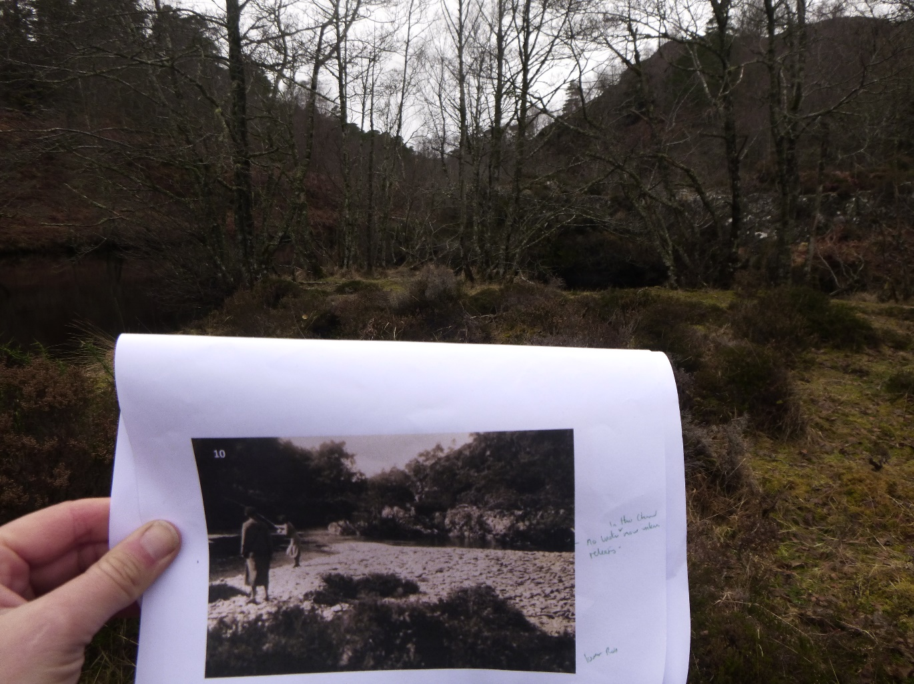

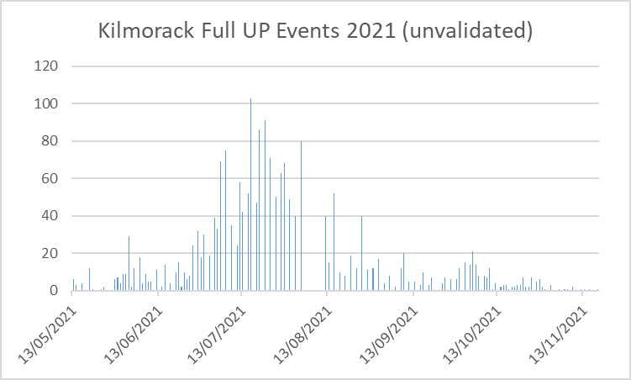
APPENDIX- Fish counts
