AS 15/09/23
Fisheries Officer/Water Bailiff Report: 1 June – 15 September 2023

This update summarises key work tasks undertaken since the last update at the end of May 2023. The focus of the last three months has been to carry out numerous patrols at different times of the day and night within our catchment, maintaining as high a presence as possible to try and deter any poaching activity.
Following the resignation of the Seasonal Water Bailiff in early May, we employed Bob Smart as our part time seasonal Bailiff. We agreed that Bob would cover Friday, Saturday and Sunday night shifts and I would patrol the catchment the rest of the time. This ensured the catchment was covered for roughly 14 hours per day on split shifts at weekends. I also undertook a combination of early morning, daytime, twilight, night, and weekend patrols throughout the season, to try and deter potential poaching activities within the catchment.
I am in regular contact with the Glass syndicate Bailiff Addie Fraser, and Ghillie George Fraser to discuss operational joint working and the sharing of any possible poaching incidents and information. I am also in regular contact with Police Scotland’s Wildlife Crime Officers and the Water Bailiffs from the Ness and Cromarty Boards to share any Fisheries intelligence.

Beauly Fishery Board Tasks
- Attended monthly team’s meetings with the Chair FSN, MSN, the Senior Biologist and TW to discuss operational plans for the coming season.
- Attended regular weekly meetings on a Monday morning with the Senior Biologist to discuss the week ahead.
- Undertook a weekly meeting with the part time Seasonal Bailiff to discuss fishery protection.
People: Community Engagement, Participation and Heritage
- Uploaded regular posts on Facebook.
- Maintained regular contact with Estate workers and Ghillies.

Monitoring
Adult fish- Kilmorack and Aigas dams/Fish lifts were checked most days.
- Maintained regular contact with SSE staff at all dams.
- Monitoring river levels on the SEPA gauges.
Electro-fishing- Delivered the Electro fishing battery to the Kyle of Sutherland fishery office and collected the Electro fishing backpack from Ardgay.
Smolts- Dismantled the 6-foot rotary screw trap on the Beauly and delivered it to the SSE yard in Muir of Ord.
- Collected Smolt Box traps from the Farrar and Glass with help from volunteers and transported them to Corff Office.

Work Plan Progress to Address the Pressures on Salmon and Sea trout
Bailiffing
River Patrols conducted 2 June – 15 September 2023
River | Patrols | Warning Letters Issued/Verbal Warnings
BAC water | 200 | 1 verbal warning
LBFS – Upper Beauly beats | 280 | 2 Official police warnings.  10 Verbal warnings
Glass | 225 | 5 Verbal warnings
Farrar | 25 | 0
Beauly Firth | 150 | 25 Verbal warnings.

Catchment patrols were arranged with Police Scotland’s Wildlife Crime Officers, throughout the season. These joint patrols have maintained a visible presence and are proving to be a successfully deterrent. The LBFS ghillies challenged a few suspected poachers on the LBFS beats during this period.

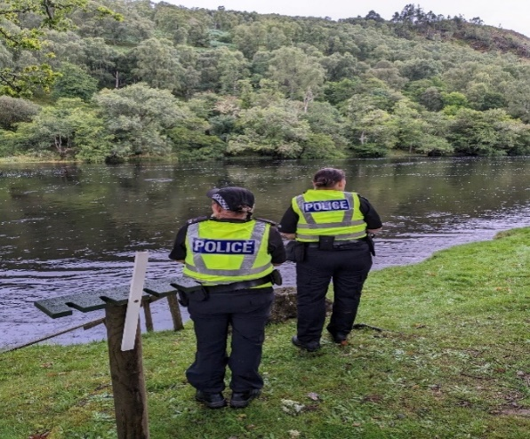
Joint patrol with Police Scotland’s Wildlife Crime Officers

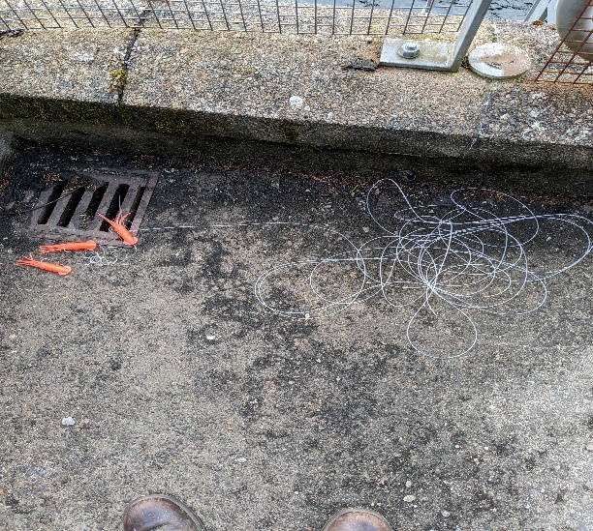

Lures were found attached to the ladder at Aigas Dam.

I have received numerous phone calls reporting possible poaching in the Beauly Firth by small scale vessels and have been carrying out as many patrols as possible. Several vessels have been inspected on arrival into Kessock pier and only Mackerel have been found to date.

Sea Bass fishermen are fishing the Red Castle area of the Firth. Advice was given to the anglers on size limit and how many fish they can retain.

Most anglers challenged this year have been tourist and foreign anglers. Advice, guidance on where to purchase fishing permits and verbal warnings were given.
I attended a Bailiff meeting at Logie Steadings Office in Forres with the Moray Firth Bailiffs and Police Scotland WCO to discuss enforcement issues.
Lovat Estate has authorised me to instal CCTV signs on the Falls beat to try and deter poaching on the LBFS beats.

A Whatsapp group was set up with Erchless Estate to inform me what days anglers were fishing their part of the river Glass. This has worked well during the season and has resulted in a decrease in call outs. There has also been a decrease in brown Trout fishermen.

I continue to foster excellent working relationship with the Bailiffs from neighbouring Fishery Boards, Ghillies, Police Scotland’s Wildlife Crime Officers, river watchers, volunteers, and staff from SSE.
Jim has kindly donated a drone for me to use for fishery protection surveys and other Board work.

Predation
- I worked with the Senior Biologist to complete and submit the Boards bird licence application for 2023-2024.
- No birds were shot during the licence period Oct 2022-May 2023.
- I continue to carry out regular sawbill counts within our catchment.
Pink Salmon
- Undertook drone work on Lower Beauly to search for Pacific Pink Salmon – very hard to spot any Redds.

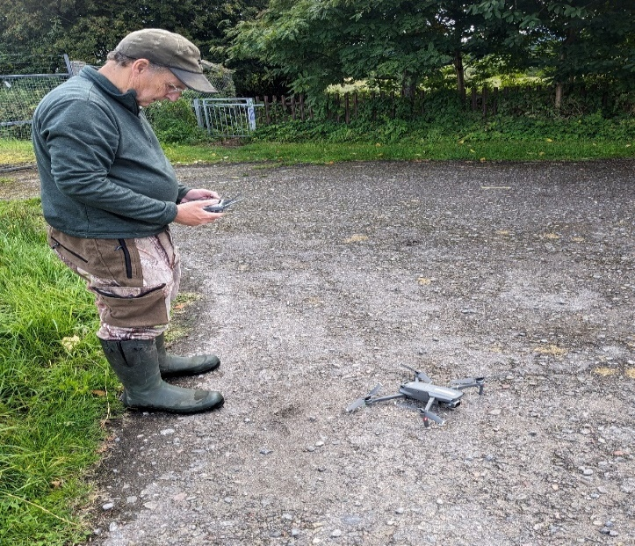
Undertaking Drone surveys with Jim Braithwaite
Invasives (Scottish Invasive Species Initiative)
- Mink traps were regularly inspected.
- SISI Volunteers hours were recorded on the Cervis database along with new volunteers.
- Completed the SISI return and contacted our mink volunteers regarding Mink equipment and provided a handover to the new SISI officer, Trudi. Showed Trudi the location of the mink traps.
- Showed our SISI officer where invasives species are within our catchment and undertook the spraying of Skunk Cabbage.
- Drone work carried out with board member Jim Braithwaite on the Lower Beauly- Estuary to check on Japanese Knotweed.

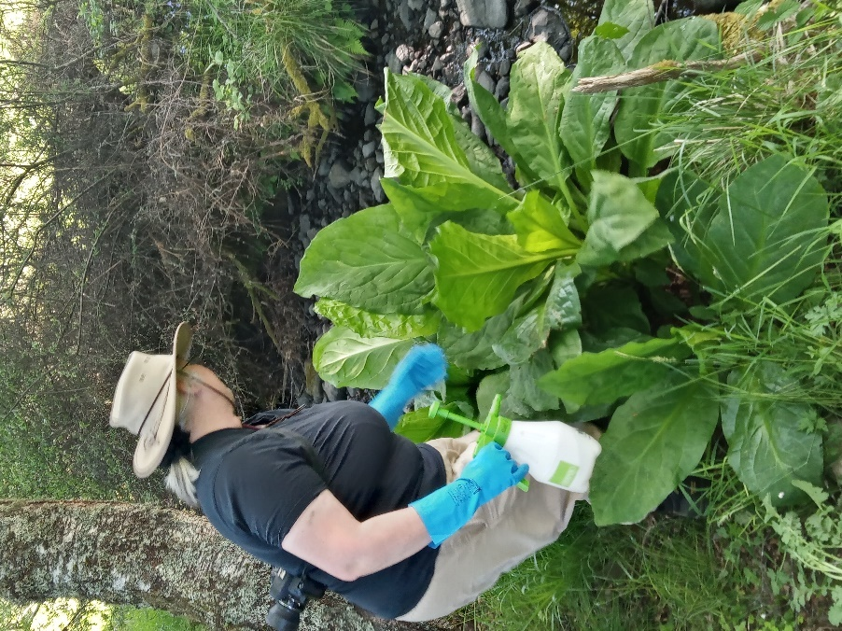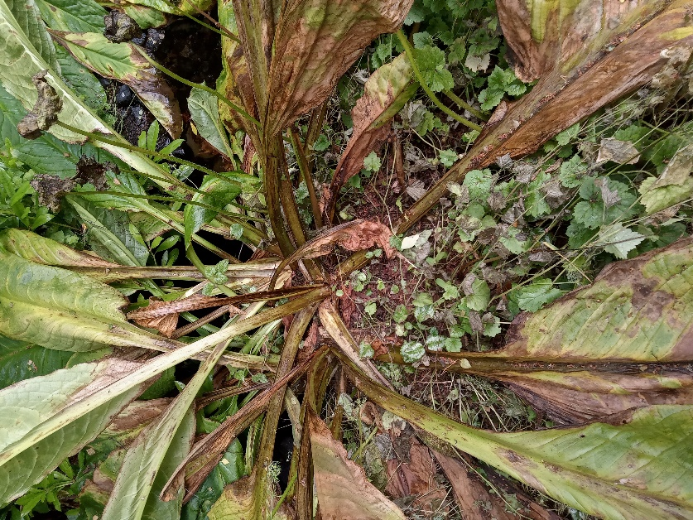
Treating Skunk cabbage with the SISI Officer at Kirkton Burn before and after pictures.

As previously stated, I have arranged for the catchment to be patrolled 14 hours a day (where possible), through a combination of patrols throughout the season to try and deter potential poaching activities. I also have been working closely with my fellow Bailiffs from the Ness and Cromarty and keep in regular contact with them.
We will continue to keep a very high profile to deter poaching activity on the rivers and along the coastline. This consists of carrying out a lot of late-night and early morning patrols. Whilst poaching activity may be declining, there is no doubt that without the dedicated professional work of the BSFB Bailiffs, the rivers Beauly, Glass and Farrar would be far more of a target for such illegal activity.
Please feel free to contact me regarding any issues on the river by email at ali@beaulyfisheryboard.org or by phone on 07786 741482.

Ali Skinner,
Fisheries Officer/Water Bailiff

