AS 10/11/2023
Fisheries Officer/Water Bailiff Report: 9th Jan – 10th Nov 2023
This update summarises key working tasks undertaken during the 2023 season. The focus for 2023 was to undertake numerous patrols at different times of the day and night within our catchment, maintaining as high a presence as possible to try and deter any poaching activity. Most of these patrols were carried out during weekends and at unsociable hours.
During the winter months there are many fishermen fishing the river, from Aigas dam upstream to the river Glass. These anglers are targeting Pike, and I regularly stop and inspect their tackle to ensure it is legal.
The Board employed a new seasonal Water Bailiff in March 23, however as he resigned in early May, the Board then employed Bob Smart on a part time basis. This ensured the catchment was covered for roughly 14 hours per day on split shifts at weekends.
I also undertook a combination of early morning, daytime, twilight, night, and weekend patrols throughout the season, to try and deter potential poaching activities within the catchment. We altered our patrols this year ensuring we patrolled the main poaching areas within our catchment especially at weekends, and this has made a big difference.
The installation of gates on the LBFS beats has also made a big difference to the number of poachers targeting those beats at weekends and this has helped with the amount of call outs that I received over the course of the summer months.
I suspect that the small catch numbers this year has kept the local poachers away and most anglers challenged this year have been tourists and foreign anglers. Advice, guidance on where to purchase fishing permits and verbal warnings was given. Wildlife cameras are deployed throughout the catchment.

I am in regular contact with the Glass syndicate and Erchless Ghillies to discuss any possible poaching incidents and share information. I am also in regular contact with Police Scotland’s Wildlife Crime Officers and the Water Bailiffs from the Ness and Cromarty Boards to share any Fisheries intelligence.

Work Plan Progress to Address the Pressures on Salmon and Sea Trout
Bailiffing
River Patrols conducted 9 January – 10 November 2023
River | Patrols | Warning Letters Issued/Verbal Warnings
Beauly Firth | 260 | 25 Verbal warnings/Advice
BAC water | 280 | 5 Verbal warnings/Advice
LBFS – Upper Beauly beats | 320 | 2 official Police warnings.  10 Verbal warnings/Advice
Farrar | 35 | 0
Glass | 280 | 5 Verbal warnings/Advice

I have found it very beneficial to have met with some of the proprietors and anglers this year, to learn more about previous pinch points on the rivers Beauly, Glass and Farrar, and on the Beauly Firth.
The part time seasonal Bailiff and I patrolled the catchment 14 hours per day on split shifts, undertaking a combination of early morning, daytime, twilight, and night patrols and weekend patrols throughout the season to try and deter potential poaching activities within the catchment. All weekends in June, July, August, and September were patrolled and we carried out targeted patrols at Kilmorack and Aigas dams.
I met with Glass syndicate Bailiff and Ghillie to discuss operational joint working and the sharing of any possible poaching incidents. I was also in regular contact with the Bailiffs from the Ness and Cromarty Boards to share any Fisheries intelligence and attended a Bailiff meeting at Logie Steadings with other Bailiffs from the Moray Firth area as well as Police Scotland Wildlife Crime Officers to discuss enforcement issues.
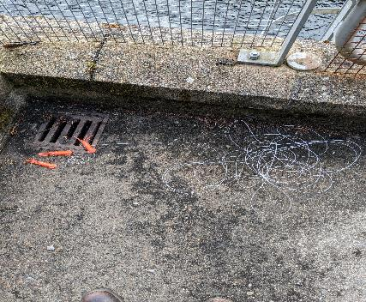
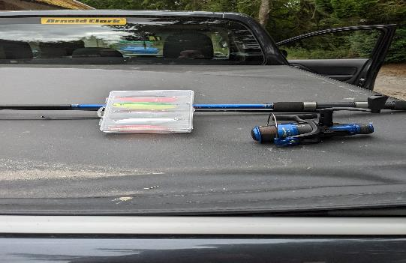
Fishing tackle found hidden in undergrowth Set lines found at Aigas Dam
at Teannasie burn

Beauly Firth
260 patrols were conducted within the Beauly Firth and 25 Verbal warnings/Advice were issued for small scale fishery incidents.
I received numerous phone calls reporting possible poaching in the Beauly Firth by small scale vessels and I carried out as many patrols as possible. Several vessels were inspected on arrival into Kessock pier and only Mackerel was found. No evidence was found of Salmon poaching. All fishing tackle was inspected. There was also an increase in Sea Bass fishermen fishing the Beauly Firth this year and I advised the anglers of the regulations on size and limits.

Beauly Angling Club and Syndicate Waters
600 patrols were conducted on the Beauly Angling Club (BAC) waters and Lower and Middle beats of the Syndicate throughout the season. I spoke to several youths regarding fishing in the BAC waters without a permit.
17 anglers were removed from the BAC and Syndicate waters for fishing without a permit and fishing with the wrong tackle. They had no Salmon. There has been a small decrease in local poachers targeting these beats this year but a small increase in foreign anglers fishing these beats. I suspect the installation of the gates on the LBFS beats has made a big difference to persons targeting these beats at the weekend. The targeted patrols at the weekends by the Beauly water bailiffs on these beats also made a big difference when compared to the last 2 years.
Reports were received of anglers keeping Kelts at Stalkers beat in early 2023. Several patrols were carried out during the winter months but as yet, no evidence has been found of illegal poachers in the area.
Glass
280 patrols were conducted on the river Glass during the season. 5 verbal warning letters were issued, for small scale fishery offences.
A WhatsApp group was set up with Erchless Estate this year informing me how many anglers were fishing their beats and what days they were fishing. This has made a huge difference to the amount of call outs I received during the 2023 season for possible poachers.
Very few anglers’ fish the river Glass until August, but we kept up a good presence in the area. I met with up with several Pike fishermen fishing the river Glass during the winter months and they passed on information on any strange activity in the area.
There was a substantial decrease on Brown Trout anglers fishing these beats this year. The anglers that we met had Brown Trout permits.
I met with the Bailiff and Ghillie from the Glass and agreed on our joint working operational plan for the season.
Farrar
35 patrols were conducted on the river with no fisheries issues.
I met with several SSE employees in the Farrar catchment and gave them both mine and the seasonal Bailiffs contact details.
I continue to foster excellent working relations with the Ghillies on the Farrar.

Police Scotland
I organised several joint patrols throughout the season with the local Wildlife Crime Officer from Police Scotland. This collaborative approach will be ongoing to deter any illegal fishing.
All poaching incidents are passed onto the Wildlife Crime Officer to record on Police Scotland’s database.
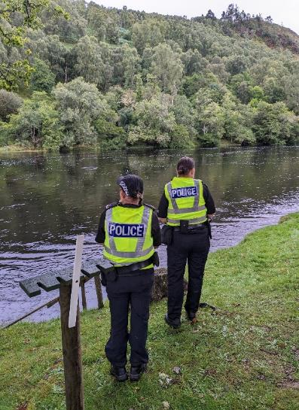
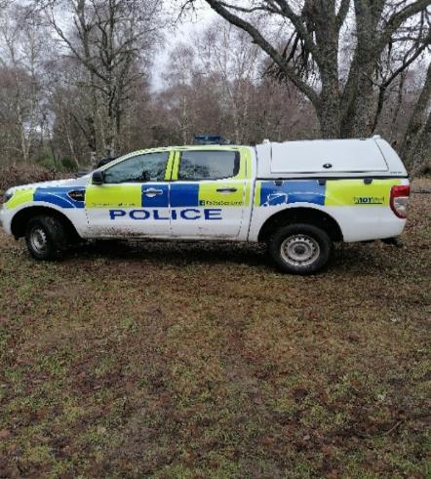

Wildlife Crime Officers from Police Scotland carrying out a joint patrol with the Beauly Water Bailiffs.

Predation
No birds were shot during the licence period October 2022-May 2023.
Compiled the bird count and completed the bird licence application with the Senior Biologist which was submitted to Nature Scot.

Barriers
Inspected tributaries for blockages/clearance within our catchment in October and November 2023.

Invasives (Scottish Invasive Species Initiative)
Mink traps were regularly inspected.
SISI Volunteers hours were recorded on the Cervis database along with new volunteers.
Completed the SISI return and contacted our mink volunteers regarding Mink equipment and provided a handover to the new SISI officer, Trudi
Undertook the spraying of Skunk Cabbage with Trudi.

People: Community Engagement, Participation and Heritage
Uploaded regular posts on Facebook.
Maintained regular contact with Estate workers and Ghillies.
Attended the opening of the Salmon season.
Ghillie and Bailiff meeting was held early season to discuss the coming season.
Responded to general enquiries from the public.

Monitoring
Adult fish
Maintained regular contact with SSE staff at all dams.
Monitoring river levels on the SEPA gauges
Inspected smolt gate slots at Aigas and Kilmorack dam with SSE employee Naveed.
Kilmorack and Aigas Dams/Fish lifts were checked most days.
Sluice gate at Aigas dam were open during February and March 2023 to help Kelts move down through the system
Checked for Salmon and Sea Trout Kelts above the dams during January February and March 2023. A few Kelts were observed.

Smolts
The river Glass was surveyed for potential Smolt trap sites and once the site was agreed upon, the Smolt trap was installed and was up and running at the end of March 2023 and monitored every day until the end of May 2023. We have requested permission to instal the smolt trap on the Erchless beat next year.
Purchased equipment for the Smolt trap. (Anchors and 1 ton concrete weight pad.)
Installed and dismantled the 6-foot rotary screw trap on the Beauly and delivered it to the SSE yard in Muir of Ord.
Installed, monitored daily and dismantled the box traps on the Rivers Farrar and Rivers Glass and transported them to/from Corff Office.
Checked for Smolts above and below both dams during the Smolt migration.
Inspected smolt gates at both dams during the Smolt run.
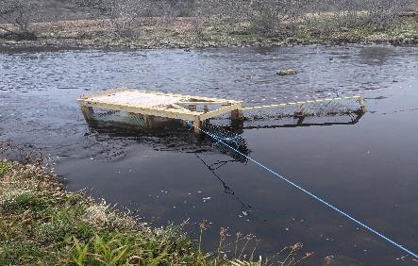
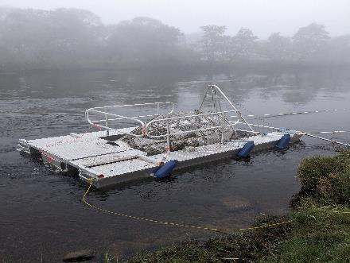

Rotary screw trap in operation at Grants pool Box trap in operation at Fasnakyle
On Middle Beauly
Electro-fishing
Delivered the Electro fishing battery to the Kyle of Sutherland fishery office for servicing and collected the Electro fishing backpack from Ardgay.
Entered Electro fishing data on the SFCC database.
Delivered the DNA fish samples taken during the smolt trap season to the Rivers and Lochs Institute at UHI Inverness.
Predation
Carried out regular sawbill counts within our catchment.
Arranged the two bird counts (Jan- April 2023) within our catchment with help from Beauly Angling Club volunteers.
Pink Salmon
Undertook drone work with Board member Jim Braithwaite on the Lower Beauly to search for invasive species Pacific Pink Salmon Redds.
Invasives (Scottish Invasive Species Initiative)
Drone work carried out with Board member Jim Braithwaite on the Lower Beauly- Estuary to search for Himalayan Balsam and to check on Japanese Knotweed.

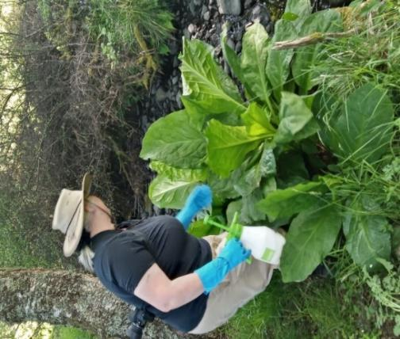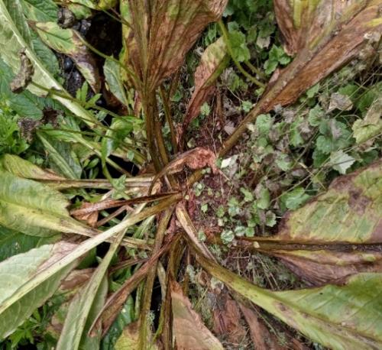
Treating Skunk cabbage with the SISI Officer at Kirkton Burn before and after pictures.

Beauly Fishery Board Tasks
Attended monthly team meetings with the Chair FSN, MSN, the Senior Biologist and TW to discuss operational plans for the coming season.
Held regular weekly meetings with the Senior Biologist to discuss the week ahead and with the Seasonal Bailiff to discuss fishery protection.
Attended regular meetings with the Senior Biologist and members from SSE to discuss fish counts/Smolt timings run and contact details of personnel to contact on the dams.

Completed quarterly reports for all Board members and proprietors.

Arranged for the servicing of all life vests and the Pat testing of all the electrical equipment in the Corff Office.

Provided training to the new Seasonal Bailiff to enhance his knowledge and enable him to sit and pass his Bailiff exam.

I would like to say a special thank you to the Seasonal Bailiff (Bob Smart) for stepping in to support me at very short notice and for all his hard work.
Many thanks also go to Jim Braithwaite for his help with the smolt traps and for donating a drone to use for Bailiff patrols.
I continue to keep a very high profile to deter poaching activity on the rivers and along the coastline. Whilst poaching activity may be declining, there is no doubt that without the dedicated professional work of the BSFB Bailiffs, the rivers Beauly, Glass and Farrar would be far more of a target for such illegal activity.
Please feel free to contact me regarding any issues on the river by email at ali@beaulyfisheriesboard.org or by phone on 07786 741482.
Ali Skinner,
Fisheries Officer /River Bailiff

