** Senior Biologist update** RW and AW 27 November 2024

This update summarises key work task progress and completion since the last update 25 September 2024. The focus of the last three months has been to finish electrofishing and data entry, collate seal app data and commence the seal license application, tying up the 2024 Adult fish sampling project, and with RW back from maternity leave on the 4 November, the important handover of work from AW. We received a flurry of data requests in November in relation to planned SSEN developments. The Action Plan has been updated, and the main focus of the next 3 months will be on submitting the seal license application, completing the 2023 electro-fishing report, and engaging SSE and proprietors on the sediment management work.

1. **Governance/ organisation**

**Staffing:**

* Seasonal Bailiff – Reece to be offered the job for the 2025 season – **Action now: Ali and HH to tell Reece**
* AW staff review doc now signed, by Frank, and with HH and filed.
* **A big thanks to AW for all his hard work this year**. AW’s last day now Monday 2 Dec. **Exit interview conducted highlighted opportunities for better governance**. Please see and adhere to [FMS’s code of conduct for boards](https://fms.scot/wp-content/uploads/2017/01/Code-of-Practice-DSFBs.pdf) (sections 2.1, 2.3) and our own [draft staff and board member manual](https://drive.google.com/file/d/1L4OiPeLXzixV2LYY9X7brkjViPJey7PI/view?usp=sharing).

**Policy docs**: Update required on progress of ‘DRAFT Staff, Volunteer and Board member manual V1’; AC informed previous Board in late 2023 that it has been sent to employment lawyer for review. **Action: AC and HH**.

**Facilities:** Iron-on logos ordered for clothing, as currently staff are unbranded when out and about.

**H+S:**

* AS due to attend first aid refresher in January. RW due refresher, RP due to attend first aid training. **Action AS to book**.
* Lifejacket servicing due in January **Action AS.**

**Budget/ finance:**

* 2025 Budget drafted for HH.
* We had a meeting with Nature Finance Project Officer Leah to review the fundability of our Fishery Management Plan actions. Most are waiting for SSE funding (e.g. smolt project and sediment management) but a few wider biodiversity actions would be suitable (e.g. Pearl mussels, riparian trees, placemaking project).

**Vehicles:** Van (Nissan Townstar) due to be with us imminently.

**FMS:**

* **FMS are recommending that all boards and trusts update their** [**catch and release policy**](https://beauly.dsfb.org.uk/files/2024/03/BDFB-Conservation-Policy-2024.pdf) **to voluntarily releasing 100% of fish.** The majority of FMS members at the AGM agreed with this proposal.On a previous consultation from MD-LOT about mandatory catch and release, we responded saying that we already have a voluntary high release rate of 98% and that changes to this could result in release rates going down BUT **as salmon are now an IUCN endangered species we are likely to come under greater scrutiny** from decision makers who will not understand the nuance to this. Some would question why we are fishing for an endangered species at all. As salmon catches go down, so does our main source of funding and we (like FMS) will have to diversify to survive. **FMS are recommending we take a lead on this**. A voluntary change to all board conservation policies would strengthen FMS’s negotiating power when it comes to protecting Salmon **and implementing the** [**Wild Salmon Strategy**](https://www.gov.scot/publications/scottish-wild-salmon-strategy/)**. For discussion.**
* FMS are currently consulting on an updated strategy.

**Training:** RW attended a Fish Health and Disease workshop hosted by FMS (UHI, 12 Nov).

***Future:******Xmas drinks Wed 18th Dec from 5pm at Comm bar (back of the Priory hotel), all welcome.*** *Order 3x signage for Lovat bridge turn off so folk can find the office.*

1. **Work Plan Progress to address the Pressures (*=priority)**

A link to the Storyboard Fishery Management Plan (Phase 2) is [here](https://storymaps.arcgis.com/stories/e2200f33a0af4ee28cc0c075094660d4), it remains live on the website, with review/updates ongoing.

**\*Bailiffing:** See AS’ quarterly report. 2024 Bailiffing review due to enable improvements for next year: **Action RW and AS.**

**\*Sediment management:** SSE are due to feedback on the two Hydromorphology reports. SSE did not attend a meeting on 19 Nov to discuss. Concern that we will not receive this feedback any time soon especially with Ross moving on. Reports will need updating based on feedback. The [sediment management project at Kyle of Sutherland](https://storymaps.arcgis.com/stories/8b3dbc7363b541db8055e38f64bd1b82) is a good example of how spawning habitat for salmon can be improved below a large hydro dam (while also benefitting Freshwater Pearl mussel). **Would the board like to visit this project??**

**\*Smolt passage**: Smolt protocol for 2025 thoroughly updated. Awaiting draft from Naveed**. Action RW** to organise meeting with SSE and SEPA to discuss what smolt protocol adherence data might be acceptable/ possible for SSE to provide*.* See ‘Monitoring methods’ section.

**\*Predation:** Preparation of a seal licence is currently ongoing with submission expected in January.

* Discussion with FMS and the Dee Board (one of four Boards who have a license to control seals for 2025-2027) are helping the Beauly seal license application process.
* The application submission period is January 1st – 31st, and this is for the May 2025 to April 2026 management period. **Important to note** - the licenses that have been granted are to protect Spring salmon – in line with the statutory requirement to return all salmon up to March 31st, the license period covers January to March 31st - therefore, if the BFB were successful in getting a license in 2025, the control period would likely not be until January to March 2026.
* **Another important note** – a method statement needs to be strictly followed, so that it is clearly shown that any lethal control used is taken as the last resort, that all other possible measures have been used, and it is done in a safe and humane manner. **Action: AW** has started the application form, and RW will complete it.
* Two LBFS ghillies put forward for the Moray Firth marksman course – FMS currently gauging numbers to inform the running of the course by UHI (hasn’t been run for two to three years). There is a requirement to provide valid marksman certificates with the application, but FMS have advised that it is reasonable to assume that we will be able to submit these when we get them/at a later date, and make that clear when submitting the application.

See predation monitoring in ‘Monitoring methods’ section below for more info.

**Invasives (INNS)/ Scottish Invasive Species Initiative (SISI):**

* With the contractor budget and mink control work budget worked to capacity, along with 28 of the 40hours for plant control work, we have seen claims paid of £6,354.68, from a budget of £6,468.
* Several Remoti traps on Beaufort and Lovat estates were seen to be wrongly assigned – some locations on Remoti system didn’t have a trap set there, and some trap locations were not on the system – AW went around all trap locations and amended on system with correct serial numbers and locations; with follow-up visits by AS and Trudi to update system further. All correct now. **Action: RW to be shown all the trap locations**.
* Trudi’s (SISI Project officer) annual review (20 Nov) postponed to December.

**Development:**

* Lower Beauly OHL data request received (SSEN via WSP).
* Beauly substation (Fanellan) data request (SSEN via WSP).
* 1x timing of works enquiry (SSEN via BAM nuttall) in relation to Black bridge upgrade
* 1x Spittal-Loch Buidhe OHL consultation pending a response **Action RW**.

1. **Monitoring Methods**

**Conservation grading:**

* Still awaiting response to our consultation submission.

**Smolt monitoring:**

* 2024 Smolt monitoring summary complete (see website).
* At the SSE liaison meeting it was decided to drop smolt monitoring for 2025, and to instead focus on delivering a smolt study in 2026 to look at smolt survival at the dams under different generation regimes. Sean Robertson (FMS) has indicated we may be able to borrow him for this project. **Action: RW** to come up with project proposal for SSE funding consideration.

**Fish Counts:**

Technical issues (‘teething problems’) with the new AI counting system were encountered again in 2024:

* 20 hours of video data were lost at Kilmorack, in August – with July and August being the busiest months for movement of fish, this means the Kilmorack count of **3450** (as of 6th November) is likely to be much higher and is estimated by Ross to be more likely in the region of **4,500** fish, possibly more.
* A delay in the system has caused a back-log of 400hours of video files from Aigas still needing processed (as of 6th November, when reported to us). We await to see how much the significantly lower count at Aigas (**2186**, as of 6th November) is increased by, but hopefully this will make a big difference to the figure, and will turn out to be the reason for the concerning discrepancy between the two dam counts.
* In reaction to another year with data loss and technical issues, further measures to improve the system will be adopted for 2025, including bigger hard drives at the dams, to hold up to 8 months of data, and using Starlink to greatly improve connectivity and upload speeds.
* **220** fish have been recorded by the Beannacharan dam counter in 2024 (up to 3rd November).

These numbers will likely increase further with any remaining fish that have moved through the dams through November, and also need to remember that these are all unvalidated counts.

|  |  |  |  |  |  |
| --- | --- | --- | --- | --- | --- |
| Past data | **2019** | **2020** | **2021** | **2022** | **2023 (40-50% data lost)** |
| **Kilmorack** | 2329 | 3374 | 3075 (missing counts 4-11 Aug) | 4982 | 2691 |
| **Aigas** | 1723 | 2864 (missing counts) | 2896 | 3432 | 2834 |
| **Beannacharan (Farrar)** | 37 (missing data) | 144 | 123 | 256 | 38 |

**Rod catches:**

* TW kindly provided the LBFS catch figures – a better year thankfully for salmon catches, with 427 fish reported, this is much closer to, but still under, the 5 year (463.4) and 10 year average (450.9).
* It will be good to receive the other rod catch data for 2024 when it is available. **Action: HH.**
* Claire at Bidwells has highlighted there were errors with the sea trout catch records for 2023 – have they been amended? And fed back to the MD? This needed sorted ahead of going back to the MD - there was a discrepancy of one sea trout between our records and theirs (which will be greater now, with the revised figures). **Action: HH and Claire to address (?).**

**Electro-fishing:**

* The Farrar genetics study (funded by Frank Spencer-Nairn) was successfully completed in August 2024 – thanks to volunteer Steve North for assisting with all 12 sites/4 days of surveys. A link to the report is [here](https://drive.google.com/file/d/1i8JZ53b5VfwFx3KdxKBERyOECMBRHTTT/view?usp=drive_link). Findings so far suggest that there are at least >243-272 inferred parents. No genetic sub-structuring is apparent. Repeat spawners and precocious parr are contributing to 18% of the fry (which is surprising). There is an increase in early migrating fish at the top of the Farrar relative to the bottom.
* 8 sites were electro-fished in summer of 2024; on the Farrar, Glass and lower Beauly rivers, and the Belladrum, Bruaich and Breakachy burns. High flows in September hampered doing mainstem surveys, so smaller burns were targeted. However low flows at the very end of the month, into October, allowed a couple of sites on the lower Beauly to be surveyed.
  + Data has been entered into the SFCC database; no detailed analysis but a general feeling (excluding the Glass site) was that the lower catch returns of 2023 are reflected in lower salmon fry numbers in 2024, and potentially also the lower sea trout catches, as numbers of trout recorded in surveys were very low on the burns that were surveyed. However this is just a few sites, and further analysis needed to compare the data with previous years before any conclusions can be drawn.
  + The site at the very top of the Glass had very good juvenile salmon numbers, with minimum estimates of 94 fry and 24 parr per 100m2. This compared with a site on the upper Farrar with 7 fry and 19 parr per 100m2. The Glass site was better quality habitat, and the Farrar site was much more suited to parr than fry, but both were randomly selected.
  + It is difficult to determine trends without many sites being surveyed.
* The 2023 electrofishing report due in January/February. **Action RW.**
* 2023 electro-fishing data needs correcting in SFCC database **Action: AS.**
* Monitoring strategy updated.

**Predation monitoring:**

**Seals:**

* Analysing the seal app data (up to 11th November - more sightings have been recorded since) reveals:
* 66 seal sightings recorded in 2024 (up to 17th November) – 60 of grey seals, five of common seals, and one unknown.
* There are multiple sightings some days, and some within a short time of each other (e.g. 4 records on the 12th April likely relate to the same animal; and 5 records on 28th August relate to two animals in the river that day).
* Seals have been recorded on the lower Beauly on 41 days of 2024 (up to 17th November).
* Seal incursions into the river are both tide and river level dependant – most sightings are said to be on or after a rising tide (tide data has not been analysed yet), and there needs to be an elevated flow to allow access up to the dam, however this likely over a wide range of flows, with only low river levels preventing access (GA, pers.comm.).
* Figure 1 below shows most sightings are clustered on elevated flow events (river level of 1m+ at SEPA Redbridge gauging station) – this makes sense in terms of access for seals up the river, and increased attraction from salmon entering and running the river on elevated flows.
* From brief analysis (only records with location detail entered in the supplementary info box), sightings at the dam are when the river level is >1m, and sightings when the river is low (around 0.5m) are of animals in the lower river (e.g. Priests and Minsters pools). Further analysis, of all sighting locations, is needed to fully understand the relationship of river level and seal access.
* AW/RW to check the FMS online guidance and produce some recommendations on how data entry (to the seal app) can be improved, and particularly in terms of the information needing recorded when the ADD is deployed to deter the seals.
* Big thanks to Ali and the ghillies, and other individuals, for using the app to record seals on the river, and deploying the ADD.

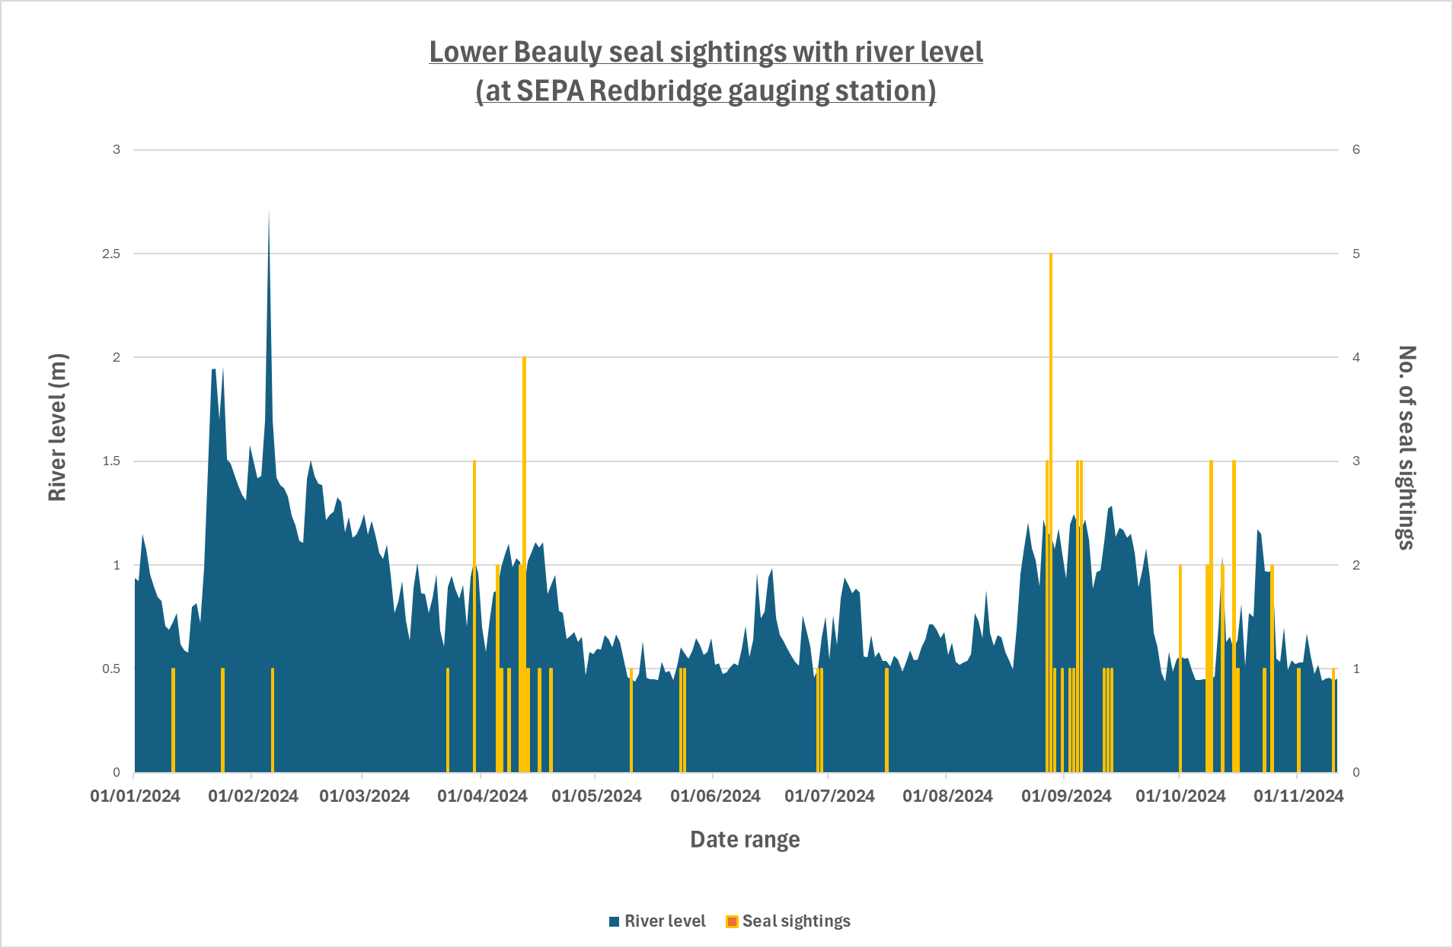

**Sawbills:**

* The first of the four 2024-2025 piscivorous bird surveys carried out on 3rd October by AS and AW.
* Revised bird survey plan in 2024, following discussion with RK – surveys in early October, December/January, late March, and early May.
* HH having license for 2024-2025 amended to have his name on it.
* Dispatchers must stick to the limits of the licence, and report accordingly

**Adult fish sampling project:**

* LBFS ghillies have kindly carried out the sampling for the 2024 Adult fish sampling project, and collected scale samples from 67 fish – these have been sent off to the MD for analysis.
* The sampling was to cover a four-month period, June to September, however no samples were collected in September.
* The fund for the project offers a potential £10,000 in 2024.
* We are still waiting to receive a report covering first three years of the project, from 2021-2023, we were advised by the MD that it would be available by the end of the summer 2024.
* This project work will eventually be used to feed into the Conservation grading - a report will be produced by MSS in the coming year as to how that will be done.

**Temperature monitoring:**

* Continues at three sites – on the Uisge Misge (upper farrar), the Abhainn Deabhag; and on the lower Beauly at Cruives (reported missing last update, but it was found at the location – high flows had hidden the wire it’s attached to).
* Monitoring temperature alongside smolt monitoring will help to predict what temperatures are triggering smolt migration; as well as looking at summer highs, and in relation to adult migration.
* Latest data collection carried out in early September 2024 on the Misge and Deabhag, and in November on the lower Beauly.

***Future:*** *Drone flyover of Lower Beauly and Lower Farrar imminent to assess location of redds to support the Sediment management work. Adult fish sampling likely to be funded again in 2025. FMS reporting app poster into fishing huts.*

1. **People: Community engagement, participation and heritage**

**Website:** updated with biologist updates and reports but board minutes are missing for 2024. **Action: AC/ HH**

**Social media**:

* Good drone footage of spawning fish taken by GA put on FB page.
* Whatsapp group for interested parties – proprietors, ghillies, bailiffs – to share pics of fish caught and availability for fishing **ACTION: AS** in liaison with FSN.

**Proprietors:**

* Fish counts and general work update sent to all proprietors (20 Nov).
* Work update prepared for BAC AGM (21 Nov).

**Anglers/ghillies:** New Biosecurity signage and disinfectant being gifted to us by FMS via funding they have secured, so need to re-emphasise the need to disinfect and keep aware and alert to biosecurity risks.

***Future:*** *Oral history project report to be completed by Louise (in her own time). Louise was asked to go to Canada to present this project (as it is very good). Once complete we can get a few copies professionally printed for the local library/ interest groups.*

*-------*

**Incidents:**

-Tomich burn dredging Investigated by SEPA and ourselves (5 Nov). 65m stretch of juvenile trout habitat affected.

-V low flows witnessed from 18-24 Nov (when salmon spawning started on the mainstem). Concerns that some spawning habitat not utilised (e.g. along the left bank at Cruives, and left bank opposite Belladrum confluence). SSE contacted.

**Written Outputs:** 2025 Electro-fishing strategy, 2025 draft budget, FMS strategy consultation, AW exit interview.

**Meetings:** SSE smolt protocol meeting (4 Nov), Operational meeting with Hamish (5 Nov), SSE Liaison meeting (6 Nov), FMS restoration fund (11 Nov), FMS AGM (13 Nov).