
Senior Biologist update RW 4 June 2026

This update summarises key work task progress since the last update 17 February 2026. The main tasks of the last three months have been to carry out the smolt monitoring as a first step of trial trap and truck mitigation, prepare for summer contract work, and move offices. The focus of the next few months will be carrying out contract work, submitting the bird licence application, and tying things up to hand over to the next Senior Biologist. Thank you for the last 6 years. I have really enjoyed working for the Fishery board and in the Beauly catchment.
- GOVERNANCE/ ORGANISATION
Facilities:-The move to the new office in Muir of Ord and container at Ferry point occurred between 22nd-30th April, with the help of seasonal help Erica. Keys have been cut, googlepin updated.
-The Canadian canoe is being stored at the Conon, and our fyke nets have been distributed amongst other FMS members due to a reduced amount of storage space in the new container.
-A lean-to/ roof structure is required to cover the chemical store. Action: ask Jim??
-It would be ideal if Lovat could lay some aggregate down to facilitate safe vehicle access to the container. Action: RW Lovat have already mentioned that this was the original plan.
- New phones for Ali and Reece received with Giffgaff SIMs. Still to complete migration away from Vodafone for internet and Senior Biologist’s phone to ensure that any missed bills do not affect staff credit ratings. Action: Clerk.
-Efish dropped off for service at GROaqua (26 March). Fraser at Ardgay to service our second kit.

H+S and Training :-H+S manual and office noticeboard updated to reflect the office move.
-AS completed A2CofC drone training
-Jim to attend efish training (24-25th June) if able.

Budget/ finance: -Updated budget sent to HH 27th Feb.
-Adult sampling invoice for 2025 sent to FMS (23 Feb).
-Work secured for FWPM surveys at Black bridge (with BAM Nutall through HED). £3,500 for staff time. Surveys due on Sundays June-July. Met with Gary Brown from BAM 9th April. 100m upstream to 500m downstream required as best practise. RAMS sent (27 May).
-RSK (Beauly-Peterhead line) habitat walkover surveys and water sampling. Depending on the outcome of the habitat survey also FWPM survey and efishing surveys? Contract value estimated at £7,600-£9,100+
-BAM Nuttall, Black bridge fish rescues (August), contract estimated at approx. £2,400.
-RGMcleod work? (Lewis underground cable)

Staffing:-We interviewed 5 candidates (1 April) and Niall Traynor has been recruited as SISI seasonal Project Officer
-We were not successful in securing a Working with Rivers Trainee due to a crossed wire between FMS and NatureScot. This is a blow as the trainee was supposed to help deliver the summer’s efishing as well as help a bit with smolts and deliver some schools education. We have expressed an interest for getting a trainee for 2027.
-My last day with the board is 17th July. Recruitment is underway.

FMS: See The Sway newsletter for a summary of FMS activities.
-Annual DSFB questionnaire completed 11 March.
-FMS hydro group. Smolt hydro email sent (24 Feb) mooting the idea of a co-ordinated approach to assessing smolt passage down borland fish passes out of hydro lochs (i.e. Beannacharan) whoosh solution. KOS shared information suggesting that lowering loch levels ahead of the smolt run can reduce the transit times of smolts through hydro lochs (e.g. loch Shin). Action: Senior Biologist to follow up.

NBFT: -Meeting 26 March at Lovat arms to discuss future direction of the trust. New trustees came forward.
-Trustee meeting 28 May to discuss potential constitution updates (new name TBC, less fishy), the Vision, Development officer, funding strategy, collaborative working. A few new trustees in place to move things on. RW has agreed to work for NBFT on a self employed basis (1-2 days/week) for the short term to put things in place for a Development Officer. This should be of direct benefit to the board in the long term.
-Meeting with Findhorn Nairn and Lossie Trust (Findhorn Watershed Initiative) plus CromShed to share updates. Elle (FWI) keen on the Bioregion approach to bring in funding for distribution to local trusts for development/ restoration work.
-AGM due in July to officially put the new trustees in place. Charlie and Jim represent the board.

- WORK PLAN TO ADDRESS THE PRESSURES (*=priority)
Our Fishery Management Plan is on the website (pdf and storyboard).
*Bailiffing: See AS’ report.
*Sediment management: We hope to improve the resilience of the salmon populations on the Rivers Farrar and Beauly below the dams by restoring spawning beds, associated juvenile habitat, and protecting the river-beds from further armouring.
-Catchment Sediment Management Plan drafted as a WORKING document to enable funding and regulatory discussions to be had with SEPA, SSER and proprietors regarding how to move forward on the rivers Farrar and Beauly. Meeting with SEPA and SSER funders on hold pending KAYA advice re Lower Beauly.
-Final 2025 Beauly efish report shared with LBFS chair, for onwards distribution to KAYA. Once KAYA have provided their advice to LBFS, this can be discussed with the board and hopefully incorporated into our Catchment Sediment Management Plan.
-FWPM presence/absence surveys conducted of Farrar gravel augmentation sites. Awaiting NatureScot advice. Action: RW to chase.
-Visit with Frank and keeper Hamish at Culligran estate to discuss access to the preferred gravel augmentation site below Cave pool. Short stretch of Argo track required. Frank and Hamish happy in principle. Visit/ quote requested with contractor (KJ Mackenzie- approved SSE contractor). Aim would be to put in a funding request to SSE (to include track and gravel) before their August budget is finalised. Action: RW/ Senior biologist
-George Skinner’s (X ghillie) daughter contacted in the search for providing old photos of the Lower Beauly (Beaufort to Lovat bridge).
*Smolt passage:-Due to high flows at the start of the smolt run, numbers of smolts at the gate slots remained very low until mid-May. Numbers of smolts rose up to a max of 450 at Aigas around 27 May- 1 June (tbc by SSE) and dropped from 1st June. Met with SSE on 1st June to check the gate slots for smolts. We estimated there being 175 (max) in G1 and 7 in G2 at Aigas. Overall smolt passage at the dams appears to have gone OK this year. Phase 2 of the smolt protocol was in place 11 May to 2 June. A closer look at flows is due to see if improvements in generation could have been made. Action: RW.
Hydro: The SSE liaison meeting occurred on 18 March. Planned outages communicated to relevant proprietors.
*Predation:
-Following on from Rob’s response (3 March) to our original email highlighting the Beauly as a potential further trial site for the detect and deter system, I spoke to Rob on 2 June.…He emphasised that the trial kit on the Dee is a long way off from being commercially available, and there is currently no commercial interest to develop it into a product. The deterrent is rented from ‘genus wave’ and there has been a considerable amount of software development required in getting different sonars to work together. Trial set-up is >£100,000, (£150,000 already spent on software development). A suitable site would have electricity supply to both banks, shallow with laminar flow (no aeration), and above saline intrusion (NTL). For a river >40m wide a second sonar is required. The 4 month trial on the N Esk saw a 90% success rate but that still means that determined specialist seals who ‘grit their teeth’ make it up past the deterrent. The winter trial on the wider Dee is the next step.
-Bird licence application and return due to be submitted last week of June. Action RW

Invasives (INNS)/ Scottish Invasive Species Initiative (SISI):
-We recruited Niall Traynor as our Seasonal SISI officer to support Trudi in her quest battling invasives across Ness, Beauly and Cromarty catchments. He started 4th May. It’s been a pleasure working with Niall so far. He comes with a high level of practical competence which has already come in handy.
-Skunk cabbage control Wester Lovat (18 May)
-Tender for SISI funded JK treatment Beauly-Estuary put out to contractors (14 May)
-End of financial year claim submitted 31 March.
-SISI case studies submitted to Jane (SISI) 9 March.
-Attended steering group 3 March.

Riparian trees: Trees delivered to Braulen estate (from Dundreggan) to support their riparian tree planting (19 March).
Development/ consultations/ advice:
-Comments to Fanellan burn fish walkover provided to RGMcleod.

3. MONITORING
Smolt monitoring: See APPENDIX for a summary of Smolt trapping 2026 and recommendations. Update email sent to the board and SSE 14 May. All smolt data has been entered by Erica.

-Kit acquired for trap and truck trial (£6,262.90 funded by Highland Nature Restoration Fund) received quite late due to procurement process. Jim made the smolt holding boxes but unfortunately due to ill health and the more pertinent office move these were not launched this year, but will be useful for future years. Action RW: to update HNRF with project outcomes and claim final third of funding (approx. £2,000).
- Jim fitted a new winch/ cable (retained for next year). Erchless hut toilet lock fixed (thanks to Niall), extra keys cut.
Thanks to: SSE for lending us their 6ft Rotary screw trap, Highland Nature Restoration Fund, Duncan Scaffold in Dingwall who supplied us with several scaffolding poles and brackets for free, Conon Fishery Board for allowing us to borrow their larger boat, Kyle of Sutherland who lent us their back box door, LBFS for granting permission to site a smolt holding box in New Pool (visit with Dave 27 March); Erchless estate, Upper Beauly, and George Fraser for allowing access to the fishing hut and river; contractor Erica; our 8 volunteers and the amazing Jim!
--
-Following our EOI to HIEF, we were invited to put in a full application (£10,000 + Match-funded with a Crowdfunding campaign to raise £20-24,000) to fund decoder and PIT tag cost (9 March). Unfortunately following the SSE liaison meeting (18 March), it became apparent that SSE wanted to see proof that we could catch the large number of smolts required to make a trap and truck operation work before granting permission to install a decoder at Kilmorack dam. SSE also communicated their need to own the asset and manage the associated maintenance etc As this grant funding would have been premature, we retracted our grant funding request. However HIEF were positive and encouraging that we should apply again in the future. The Marine Fund were also contacted to ask if assets secured through the fund could be transferred to SSE- no response. Action: RW to chase and update MD with outcomes.
-Met with SSE at Aigas dam (1 June). Chris has mentioned that costings are likely to be much higher than anticipated as debris mitigation would include locating the decoder underneath the flume (i.e. a new flume would have to be made and re-installed). RW had contacted Biomark about costings but better done through Chris (SSE) Action: Chris to contact Biomark.
-ICES tagging return 2025 completed (5 March).

Fish counts: April fish counts received from SSE and distributed to proprietors (20 May). 18 salmon to 10 May at Kilmorack with >56 kelts net movement downstream. May fish counts have been requested from SSE.

Electro-fishing:-2025 electro-fishing report approved by the board 2 June following edits. NB: this is not available through the website due to potential commercial interests. i.e. we should charge before providing SSEN with this information.
-2025 Efish data input to SFCC database (24-25th Feb).
-draft 2026 plans involve contract work for Beauly-Peterhead OHL, and baseline surveys of R. Farrar (with drone habitat mapping) ahead of gravel augmentation. Re-survey of R. Beauly would be ideal if there is time/ resource.
-Erica corrected 2023 data in SFCC database. Action: Senior Biologist: The 2019 NEPs data still needs entering.

Predation monitoring: Bird counts conducted 7th April, 12th May (smolt run) and due around 13th July (highest bird numbers).
-Reporting of specialist seal presence in the river continues in the FMS reporting app.

- PEOPLE: COMMUNITY ENGAGEMENT, PARTICIPATION AND HERITAGE
Oral history: project info sent to Al at the River Dee to help them conduct their own Oral history project (26 Feb).
Website: Highland Nature Restoration Funding acknowledged under ‘News’ (8 April). Updated with Senior Biologist March update, Seasonal Bailiff phone number, new address details, 2025 efish report (no link).

Species on the Edge: Reviewed their draft comic illustration summarising the mystery and conservation of eels.

Social media: SISI seasonal job ad (25 Feb), BAC ladies day post (27 Feb, 23 March), Smolt monitoring with Highland Nature Restoration Funding acknowledged (25 March), Smolt monitoring (8, 19, 24 April), Duncan Scaffolding smolt monitoring (27 April), Various bailiffing and SISI posts.

Proprietors:
-Beauly Angling club flows reviewed, with input from Iain Morrison. Action: RW to refine est number of angling days lost
-emailed out April fish counts and new office details (20 May).
--------
Incident: 7 May- possible sewage incident near Balmore (AS attended).
---------
Written outputs: Annual report draft (4 June), 2025 Beauly efish report (2 June), Updated Catchment Sediment Management Plan (21 May).
Meetings/ chats: SSEN (23 Feb). Dave LBFS ghillie (27 March), Biomark (5 March), BAM Nutall (9+16 April), Charlie (21 May), SSE (1 June), Frank SN (22 May), FMS (22 May), FindhornNairn and Lossie Trust and CromShed (26 May), Rob Harris SMRU (2 June).
Office move completed at the end of April 2026 (Reece, Ali, Ruth and seasonal help, Erica)
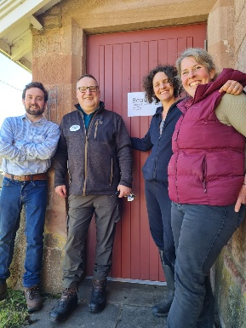

APPENDIX- SMOLT TRAPPING 2026 AND FUTURE RECOMMENDATIONS
The project proposal for trial trap and truck mitigation is on the website. This year the focus was on catching more smolts to see if this project is viable.
Trapping occurred between 6 April-6 May- a shorter duration than expected due to debris damaging the trap. A total of 536 smolts were captured, with >100 smolts captured on 2 nights once the trap was in the main flow under medium flow conditions (prime position). High flows in mid April meant that the trap was operated on the near side of the main flow initially (due to H+S/ boat access considerations).
Smolts are most likely to run in elevated flow. Getting the trap into the main flow this year saw an improvement in capture numbers but with it came the risk of catching debris.
Although impossible to say how many we theoretically could have caught if the trap had been running for another week or so (as it all depends on flows and trap position), perhaps we could have caught another few hundred, so in total <1,000 with the current set-up.
We went through the whole process of transporting smolts once with 7 smolts. Reece, Jim and Erica were trained in PIT tagging, fish processing and trap operation.
Below is a brief summary of this year's captures (moderate-good numbers when trap is in main flow under medium-elevated flow, low numbers in main flow during low flow) compared with 2024 (trap operated at side of main flow- consistent moderate numbers). The smolt run seemed to be roughly a week later than previous years due to the cool water temperatures. 2024 saw a total of 524 (complete season, approx temperature threshold reached on 22nd April). So overall you could say that running the trap this year in the main flow was more successful, but we need to manage the debris issue.
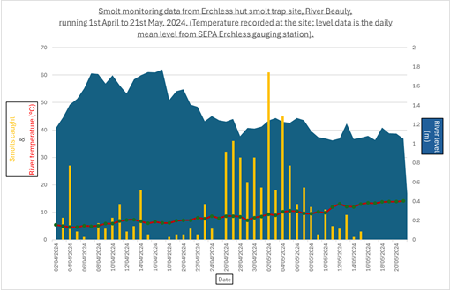
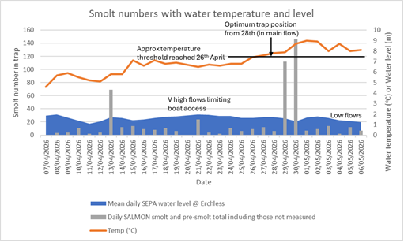

Recommendations:
1)Review the evidence- Do we think there is a problem with smolt passage associated with the dam infrastructure (slack water, pike, turbines, sub-lethal effects) to warrant the cost in seeing if Trap and Truck mitigation could help? Up to now we have designed a study to look at whether trap and truck mitigation could help improve smolt migration out of the catchment and resultant adult return back to it. This has been in the context that it would appear there are numerous potential issues with the route smolts have to take out of the catchment. There appears to be a delay of about 4 weeks of smolts navigating the slack water between Erchless and Aigas, where predation by pike in the latter half of the smolt run is likely to be greater.
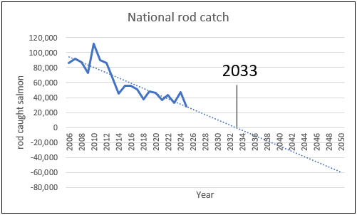
BUT there have been no reports of dead smolts in recent years below the dams due to the flow mitigation in place, and smolts trapped at the slots seem as low as practically possible when generation is sufficient/ smolt protocol adhered to. If there was a serious problem with smolt passage at the dams we would see a steeper decline in adult return compared to the national trend, but this does not appear to be the case. Based on the current trend of downward rod catch, the decline on the Beauly is slightly slower than what is being seen nationally, and the associated theoretical ‘zero-day’ figure for rod catch on the Beauly would be slightly later than for the national theoretical zero-day.
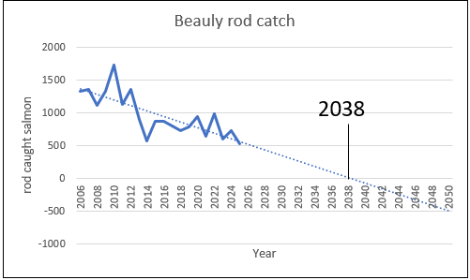

Of course, the rod catch, zero-day approach is far from perfect. For example it does not account for the declining level of catch effort due to there being less anglers now than in previous years, the fact that angler decline rate may differ locally to nationally, and also the fact that if there are fish in the river, this does not necessarily mean anglers will catch them. The zero-day approach also does not account for the numerous factors playing out at sea which are unlikely to follow a linear pattern. But given the gaps in fish count data in recent years from the Beauly, rod catch may be the best comparison that can be made for now. Please note the predicted ‘zero-day’ based on Aigas counts is around 2045.
Trap and Truck is currently carried out by the Conon and Kyle of Sutherland boards in relation to hydro loch infrastructure- the slack river morphology on the Beauly is likely to pose some sort of bottleneck to smolt survival but is likely to have less of an impact on smolts compared to hydro lochs. See literature review.
A recent look at fish counts (September 2025 update), in relation to sea survival and estimated smolt output suggested a higher adult return than expected (above the national average). It is not clear if this is due to higher smolt production than estimated (perhaps due to the unnaturally abundant parr habitat below the dams), or higher sea survival than average. Either way, it does not look as if the Beauly is struggling relative to other rivers. In fact, it is holding up better than most. This is reflected in the river currently being graded as ‘Good’ and in the top 15% of rivers assessed by Marine Directorate (but again, this method of assessment is far from perfect) and the grading is likely to drop in due course.
Action RW: to look at this in more detail

2) If continuing…
If it is deemed worthwhile to continue exploring this we will need to drastically up our capture efficiency to enable the assessment and potential implementation of this measure.
Option A- Run two traps
One of the main issues we have is the width of the river. We could run 2 smolt traps side by side hopefully to double smolt captures to a theoretical <2,000/ season. This would require purchase or hire of a second smolt trap.
To buy a new one might cost c£50,000 (ask proprietors to fund?), or otherwise consider leasing the Conon’s 8ft trap to run close to the bank with the SSE 6ft further out. Please note if we borrowed the Conon’s trap we really cannot afford to damage it as we wouldn’t want to damage our relationship with them. I suggest running theirs closer to the bank out of the main flow and resultant debris, and aim to run SSE’s 6ft in the main flow, at night only or with debris mitigation.
Considerations: staffing (a minimum of 4) to launch and bring in both traps. 2 staff to monitor the traps. Insurance. Cost/ logistics associated with transporting the 8ft trap to and from Erchless. Extra cost in terms of extra rope/ fenders/ shackles required. Two daily visits to the site would significantly impact on other work.
If we scrap releasing tagged smolts with untagged counterparts then we would halve the number of smolts required to capture and tag. We would need approx 4,000 smolts (2,000 for each treatment), which may take us 2-3 years to capture with the set-up above plus 2-3 yrs to monitor adult return.
Option B- Improve on what we’re doing already
-Run the Conon’s 8ft trap at the side of the main flow to increase our capture width but avoid debris damage.
-Install a debris guard to the front of the 6ft trap, with wings to increase the capture width. I do not know how straightforward this would be yet.
-Only run the trap at night to reduce the time the trap can be damaged. Purchase a bigger boat so the trap can be accessed in high flows as well as med-low flows. The extra daily visit involved would impact on other work.
Theoretically based on the extra quarter-third capture width, we may trap 1,300 smolts/ year and so could conduct tagging over 3 years based on scrapping releasing tagged smolts with untagged counterparts.
Option C- New site
It may be worth re-visiting the idea of smolt trapping on the Farrar (one site was identified just below the ford below Uisge Misge with the habitat above perhaps yielding 2,946 smolts. Trucking would occur over 10km and avoid Loch a’ Mhuillidh and Loch Beannacharan (both likely to be significant bottle necks to smolt survival). This option was discounted in 2025 in favour of the R. Beauly as any trap and truck operation would want to focus on large numbers of smolts to make it worthwhile.
Please note SSE have suggested using Teanassie burn as a smaller trial to show the effectiveness or otherwise of trap and truck around slack water and Kilmorack to help bring SSE fully on board however this has been discounted as it is estimated that only 100 smolts would be produced from Teanassie. (500m length x 5m average width= 2500m² divide by 100= 25. 25 x 4 smolts per 100m2= 100 smolts total).

Practical considerations
A team of 4 would ideally be used to deliver tagging work during peak smolt run (20th April- 10th May). This would be two tagging teams, with one team shuttle running smolts every couple of hours.
A team of 2 (led by either Senior Biologist, Erica, or Jim) could do the tagging with data recording and smolt transport out-with the peak run. Although ideally another 2 staff would be on-call in case large numbers of smolts are captured.
On a 1-per-2min-basis, a single tagging team (2 trained persons) could tag up to 30 smolts an hour, so over 5 hours (practical considerations accounted for e.g. breaks, smolt transport, kit set-up) 150 smolts could be tagged per day. If two teams are used up to 300 smolts could be tagged per day.
BioSS stats advice supports the trap and truck monitored trial to be done over several years so that findings apply over a range of different sea conditions. Jackie Potts recommends the use of ‘mixed models with random effects’ to allow for differences between years.
Costings
The costings for this project have gone up considerably following the visit with SSE at the dams on 1 June due to the debris mitigation required.
Another smolt trap £50,000 ish?
Decoder set underneath new flume £50,000 ish?
2 electronic measuring boards for 2 pit tagging teams….
Action RW: to update costings with input from SSE.

